# 

# BANGALORE UNIVERSITY, JNANA BHARATHI CAMPUS



**A PROJECT REPORT**

**ON**

**“Smart Classroom Automation with the help of IoT”**

**Submitted in the partial fulfillment of the requirement for the award of degree of**

**Bachelor of Computer Applications**

***Submitted by***

**NISARGA S (U03FS21S0012)**

***Under the guidance of***

**Mrs. ARPITHA J C**

**Assistant Professor**

**KLE Society’s Degree College, Nagarbhavi, Bangalore-560072**

**2023-24**

# KLE Society’s Degree College

[Affiliated to Bangalore University, Jnana Bharathi Campus, 3rd Block, Nagarbhavi 2nd Stage, Bangalore – 560072]

**Bachelor of Computer Applications**



**CERTIFICATE**

This is to certify that the project entitled **“Smart Classroom Automation with the help of IoT”** is bonified work carried by **NISARGA S** with USN: **U03FS21S0012** with in partial fulfillment for the award of degree in **Bachelor of Computer Applications of Bangalore University** during the year 2023-2024.The project report has been approved as it satisfies the academic requirement in respect of project work prescribed for the said degree.

**Signature of the Guide Signature of the Co-Ordinator**

**Asst. Prof. Arpitha J C Dr. Parvati N Angadi**

**Name of the Examiners: Signature**

**1.**

**2.**

**DECLARATION**

**I**, **NISARGA S** with **USN U03FS21S0012,** Studying in 6th semester **BCA, KLE Society’s Degree College, Nagarbhavi, Bangalore** declares that the project work entitled **“Smart Classroom Automation with the help of IoT”** submitted to Bangalore University during year 2023-2024 is an original work carried under the guidance of **Mrs. Arpitha J C Assistant Professor, Bachelor of Computer Applications, KLE Society’s Degree College, Nagarbhavi, Bangalore** and this project is submitted in the partial fulfillment of the requirement for the award of degree of Bachelor of Computer Applications.

**Date: NISARGA S**

**Place: Bangalore**

**ACKNOWLEDGEMENT**

I consider it a great privilege to place my deepest sense of gratitude and sincere thanks to beloved Co-Ordinator **Dr. Parvati N Angadi** for her cooperation, guidance, and supervision during this project.

I am extremely thankful and wish to express my sincere gratitude to my respected guide Assistant Prof. **Arpitha J C** for her kind co-operation and providing valuable suggestions and constant encouragement for the improvement and successful completion of this project.

I would like to express my pure and sincere thanks for the guidance, timely advice, support, sincere co-operation, suggestion, ideas provided by all the teaching staff and non- teaching staffs of the **Bachelor of Computer Applications, K L E Society’s Degree College, Nagarbhavi, Bangalore**

**NISARGA S (U03FS21S0012)**

**ABSTRACT**

The internet has become a daily necessity to utmost of the effective participants in which we interact and communicate among ourselves by switching data and information sensed about the environment and atmosphere. From this IoT they relate autonomously to the real-world events and offer us with services with or without direct human interference. Automation of the surrounding environment of a modern human being allows increasing his work efficiency and comfort. An automation system is a precisely planned change in a physical or administrative task utilizing a new process, method, or machine that increases productivity, quality, and profit while providing methodological control and analysis. There has been a significant development in the area of an individual’s routine tasks and those can be automated. Automation gives an individual the ability to remotely or automatically control things around the home using the mobile application. Smart classroom is the representative of the modern teaching. With the advent of modern technology it becomes easier for the students as well as teachers to perform their task more efficiently. With the aid of modern technology it has become easier for the students and teachers across the world to get a good grasp of the theoretical as well as practical knowledge. Through technology it has become easier to visualize anything in 3D and therefore the technology helps us to be conversant of the nuances of any concept. The smart classroom is rectification to various problems that teacher as well as student faces inside the classroom. This project aims to make use of the modern technology for helping the teachers in utilizing more time for teaching and students to easily get access to the electronic devices.

**Sl No Chapter Name Page No**

1. INTRODUCTION 1-2
2. LITREATURE SURVEY 3-6
3. EXISTING SYSTEM 7
4. PROPOSED SYSTEM 8-10
   1. Advantages
   2. System Architecture
5. MODULES 11-28
6. SYSTEM DESIGN 29-33
   1. Requirement Analysis
   2. Data Flow Diagram
   3. Use-case Diagram
7. CODING 34-35
8. TESTING 36-42
   1. Types of Testing
   2. Testing Results

CONCLUSION AND FUTURE ENHANCEMENT 43-44

SCREENSHOTS 45-52

REFERENCES 53-54

**Sl No Figure Name Page No**

1. System Architecture 9
2. Data Flow Diagram (level 0) 30
3. Data Flow Diagram (level 1) 31
4. Data Flow Diagram (level 2) 32
5. Use-case Diagram 33

# CHAPTER 1

**INTRODUCTION**

The smart classroom concept described from a completely new perspective that is real-time feedback on activity around environment using Internet of Things (IoT). The main contribution of this proposed system is an innovative approach to a smart classroom environment and multidisciplinary research subject. This perspective demands an understanding of problem statement so as to define parameters with further aim to create a better prologue for the system implementation. Our Proposed system mainly focuses on use of the monitoring and sensing technology to save the energy and detect the thief in an intelligent environment. The information collected can provide insight into classroom activity level by correlating the movement's existence and intensity.

Automation has been a feature of science fiction writing for many years. Since the early 20th Century following the widespread introduction of electricity into the home, and the rapid advancement of information technology. Automation refers to the application of computer and information technology for control of home appliances easily. It is an automation of the home, housework or household activity.

Classroom automation may include centralized control of light, appliances, temperature and other systems, to provide improved convenience. The popularity of room automation has been increasing greatly in recent years due to much higher affordability and simplicity through smartphone and tablet connectivity. The concept of the "Internet of Things" has tied in closely with the popularization of home automation. Through the integration of information technologies with the home environment, systems and appliances are able to communicate in an integrated manner which results in convenience, energy efficiency, and safety benefits as we are using **Arduino.**

In modern educational environments, technology plays a crucial role in enhancing the learning experience and optimizing resource usage. A smart classroom automation system leverages IoT and embedded systems to create a more efficient and interactive learning space. This report discusses the development of a smart classroom automation system focusing on IR-based student presence detection, temperature sensor-based fan control, and LDR-based light switching.

Creating a report on a smart classroom automation system requires an in-depth explanation of each section. Here's a detailed outline for the report, including the key points to cover in each section.

# CHAPTER 2

**LITERATURE SURVEY**

1. **Using Convolutional Neural Networks for Smart Classroom Observation**

Classroom observation is one the primary tools for providing teachers feedback on their classroom practices. However, classroom observation is expensive and may suffer from bias. A partial automation of this process should go a long way towards improving the quantity and quality of feedback provided to a teacher that may eventually lead to better education. This paper presents the design and implementation of a Convolution Neural Network (CNN) that used class observation audio data to classify classroom activities into those based on the Stallings Classroom Snapshot. Data consisting of 859 audio episodes taken from a variety of semi-rural schools was used to train a CNN to classify the audio episode into one of six Stalling categories; Classwork, Classroom Management, Lecture/Demonstration, Practice & Drill, Discussion/Question and Answer, and Reading Aloud. The resulting model yielded a best accuracy of 89.97%. The model performed better than previous model built using KNN and Random Forest. The 20 MB model implementation of the CNN on an iPhone SE using Core ML yielded an average response time of 0.8 seconds/inference (sd = 0.01).

1. **Smart Classroom Services System Design Based on Services Computing System**

Smart Classroom is defined as a concept that supposed to accommodate synchronous and asynchronous learning using technology that integrates traditional and distance learning to cover its learning services by using artificial intelligence-based technology. The smart classroom also utilizes the connection of smart devices as a support so that teachers and students can approach various learning styles, participate interactively and share content. While the current smart classroom system mostly provides classroom environment, the proposed design of the smart classroom in this research will be consisted of designing a smart classroom system that covers distance learning activities under Smart Learning System (SLS) and in-class learning activities in Smart Teaching Environment (STE). SLS facilitates distance learning by enabling interactive teaching, customized learning, learning analysis, and ease of document access. STE is a class environment that utilizes a variety of smart devices to support in-class learning activities. By using Service Computing System Engineering Framework, SLS and STE will be integrated to fulfill the need for learning activities alignment in our education system by creating service innovation of smart attendance. While in-class students' attendance will be recorded by existing attendance recording methods, distance learning students' attendance will be recorded by applying smart attendance in SLS utilizing artificial intelligence to trigger randomized pop-up quizzes for attendance evidence. The result of the randomized quiz submissions will be validated for attendance student report based on defined parameters of class attendance. This proposed design of the smart classroom will be evaluated by calculating the cohesion and coupling degrees as evaluation principles for service-oriented software design. In conclusion, the proposed smart classroom has a main vision toease the implementation of learning activities within in-class and distance learning.

1. **A Survey of Pedagogical Affordances of Augmented and Virtual Realities Technologies in loT - Based Classroom**

Education has become a crucial issue all over the world due to its contribution to societies' development. This article emphasizes the increasing interest in enhancing the learning and teaching process in a smart classroom. Based on that, we investigate the affordances of augmented reality (AR) and virtual reality (VR) technologies in educational sector. Our objective is to discern the main potential uses of these technologies to help teachers to transmit knowledge efficiently and effectively, and assist students to comprehend and retain it. In fact, these technologies could enhance education if they are well integrated into the educational activities. This article highlights the affordances of AR/VR technologies, and lists the cases where these technologies facilitate teaching and learning in smart classrooms.

1. **A Smart Phone Integrated Smart Classroom**

Smart phones are playing a vital role in our day-today life, especially in the field of education. A student can use his personal smart phone for carrying his softcopies of his lecture notes (as storage device), for reading the lecture notes (display device), even it is a complete encyclopedia due to the technological inventions in smart phone area. Even though smart phones have all these educational advantages, mobile phones are banned in many educational institutions as students misuse the phones during the class, by chatting with friends, playing games... This project involves research and survey to identify how usage of mobile phones at education institutions can be made under the control of authorities and how 1000s of lecture hours can be saved in a year using this device. We propose a mobile application which will help institution authorities to control the students' mobile phones and attendance will be taken by the students itself for saving the time of taking attendance. Students will be forced to run this application as their attendance will be marked through this application. This will also save the lecture time to some extend and will reduce the chances of students marking proxy attendances. Authorities can configure the list of white listed applications students can use in their phones when they are inside the campus.

1. **Smart classroom: Design of a gateway for ubiquitous classroom**

In educational environment, the use of new pedagogies such as collaborative learning requires an evolution from a traditional classroom model to active classroom. The students should be able to share resources to collaborate with each other through computers, tablets, or other devices. The design of smart classroom should enable the control of audio visual equipments, projectors, interactive whiteboards, in order to facilitate interaction among teachers and students. Ubiquitous computing or pervasive computing is a concept where processors and sensors are embedded in various physical objects to form a network and communicate information. Applying the pervasive computing can facilitate the collaborative learning by creating a smart learning environment. The ubiquitous classroom should be able to support interaction of heterogeneous devices connected through wireless links to a gateway. This paper presents a model of classroom that makes several smart devices such as laptops, tablets, projectors connected through a gateway in order to encourage communication of information between learners and the smart environment. Also, the gateway manages classroom smart devices by automatic detection and connectivity and it serves as application execution platform. Finally the gateway allows the classroom to be remote managed as well as the remote integration of application.

1. **Creating smart classrooms to benefit from innovative technologies and learning space design**

When the discussions about bringing changes and innovations to colleges is invoked, administrators and academicians often either refer to curriculum and program reforms or updating the Information technology (IT) resources and labs to address the needs of industry and government agencies. But there is another area equally important where changes are needed to take place in order to create a more innovative and engaging learning environment. It is the classroom design and infrastructure. Currently, classrooms are designed in such a way to provide face-to-face and group work learning experiences to students. Though most of them use laptops and hand-held devices including iPads as computing devices and enjoy a multitude of apps to interact with teachers and peers, all of this is still happening in the cyberspace. There is a need to move to the physical world of smart spaces in order to create smart classrooms. Our learning environments including our desks, whiteboards, classroom walls are all expected to come alive with technology. This can happen by integrating smart boards and walls, interactive projectors, new input and output devices, and sensors. This paper proposes a framework for modeling and understanding smart classrooms that are effectively and flexibly designed as spaces, student-centered, integrated for collaboration and information capture and sharing, and which take advantage of social networking.

# CHAPTER 3

**EXISTING SYSTEM**

Many of the home automation systems have been designed using different technologies. By using WIFI based classroom automation System we need to connect over an internet and make a call /message to control class room devices. It was more time delay and complex system. By using bluetooth classroom automation system we can also control all the class room devices. But the main disadvantage is range over connecting the devices. Some authors designed classroom automation using Wi-Fi as well as Bluetooth. But in those design they have implemented only ON/OFF functionalities. In our design we have implemented ON/OFF functionality along with the voltage variations and all the classroom devices are controlled by using android applications.An ideal classroom is an environment in which teachers are able to focus completely on their lectures and the students are able to concentrate on the information they are being conveyed. Unfortunately, this does not happen in most of the Indian Classrooms. During first ten minutes of every class hours, time is usually wasted in many ways such as manually recording student’s attendance one after another in the attendance register. Other disruptions also occur throughout class time such as temperature and light variation in summer and winter seasons respectively. These problems cause affected students to wander around the class guessing for the right switch and adjusting it to equilibrate the environment back to satisfying or comfortable conditions. This causes disturbances for both teachers and all the other students, and so to eliminate these irritations an automated classroom is created which allows the classroom to become more efficient, and eliminate any human assistance in controlling the atmosphere.

# Disadvantages of existing system

* Time consuming
* Relatively high cost
* Contains minimum number of automated systems
* Students and teachers will get disturbed
* Electricity is wasted due to carelessness

**CHAPTER 4**

# PROPOSED SYSTEM

As for this project, the proposed solution is to develop an economical smart classroom system without increasing the complexity and using off the shelf components to reduce the cost and open source software to get around licensing requirements of software. The sensors will be controlled with the help of Arduino, and the website and GUI part has been developed on Visual Studio (2013), both of which are FOSS (Free Open Source Software). Arduino is an opensource prototyping platform that provides easy-to-use hardware and programming environments. It is relatively inexpensive compared to other microcontroller-based platforms like Beagle Bone. Thus, creating an economic and energy efficient system development. The First objective is to automatically control the fan, lights and projector. The idea is to plant several sensors around the classroom and give a calculated feedback to the response these sensors receive. An example would be having PIR sensors around the class room that would detect the presence of human and turns the fan ON or OFF. The Second objective is to detect Class Room Temperature, Humidity and motion detection with IR Sensor.

**Objectives:**

1. Automate control of lights and fans based on student presence and environmental conditions.
2. Enhance energy efficiency and reduce operational costs.
3. Improve the overall learning environment in classrooms.
4. Provide a scalable and adaptable system for various classroom sizes and types.
5. Ensure ease of use and minimal maintenance.
   1. **Advantages of proposed system**

* **Energy Efficiency:** Automated control of lights and fans ensures they are only on when needed, reducing energy consumption.
* **Enhanced Learning Environment:** Maintaining optimal lighting and temperature conditions can improve student concentration and comfort.
* **Convenience:** Automation reduces the need for manual intervention, allowing teachers and students to focus more on learning activities.
* **Cost Savings:** Long-term energy savings can lead to reduced operational costs for educational institutions.
* **Useful for Handicapped Students:** This project helps handicapped students by introducing automation. Since some may not have hands, legs or other body parts therefore automation comes in hand for handicapped students.
* **Used in Industry/Homes:** This project can be used in any areas such as industries, homes, hospitals etc.
* **User Satisfaction:** The systems provided convenience and ease of use for both students and teachers, reducing the need for manual adjustments.
* **Scalability:** The modular nature of the systems allows for easy scalability and customization based on the specific needs of different classrooms or educational institutions.
  1. **System Architecture**

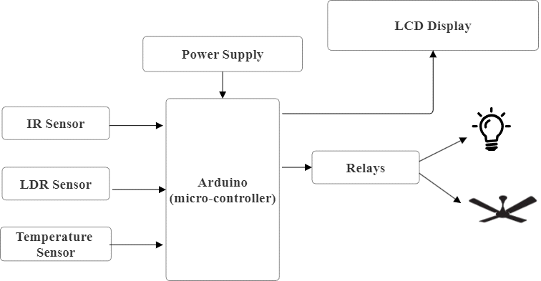

Fig. 1 System Architecture

**WORKING**

Initialize the system. Read day and time. Check whether it is on schedule or not. If it is on schedule read the status of temperature, LDR, IR sensor. If temperature is greater than set temperatures turn on fans as per IR sensor. Else switch off all fans. If light intensity is greater than set value switch off all lights. Else switch on lights as per IR sensor. If it is not on schedule switch off mains.

This project model is composed of different sensor types. Those sensors can help to assess the activity occurring outside the classrooms. We use IR sensor (passive infrared sensor) to locate activity outside the classroom. That gives us a 0 or 1 output. If 0 occurs means that no motion is detected or if it provides 1 means that motion is detected outside the classroom. This IR sensor

operates within 6 meters. We use LDR, which is a Light-based Resistor and its resistance increases or decreases depending on the strength of light in the classroom, for the automatic light cycle in classroom. So if the weather is cloudy in the rainy season and darkness is there, the lights will be ON automatically. Whole layout on Arduino will be completed. Where Arduino is forum for open-source electronics. That is used for the software and the hardware. Arduino boards may use a sensor to read input lights, a finger on a switch. This whole project is based on the Internet Of Things (IOT). That makes for a smarter classroom. IR sensors sense people’s movements near classroom and control the fans and lights. Occupancy controls were used and are still used. An occupancy sensor is an illumination control system that senses occupancy, counts the persons inside the room and sends the signal to the Arduino. The exact individual count will be reflected in the LCD panel. Sensors are not workable at any time, so large numbers of sensors are helpful in preventing any errors.

# CHAPTER 5

**MODULES**

# The modules are:

# Arduino

1. LCD
2. LDR
3. Relays
4. Temperature sensor
5. Arduino IDE

# Module 1: Arduino

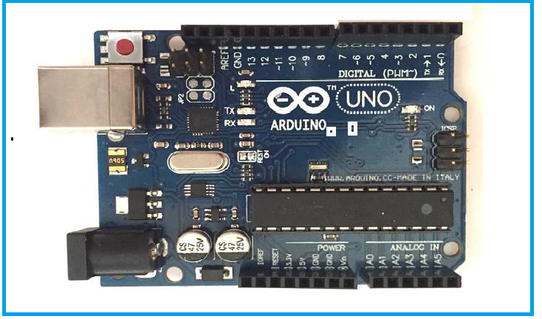

Fig: Arduino Uno board

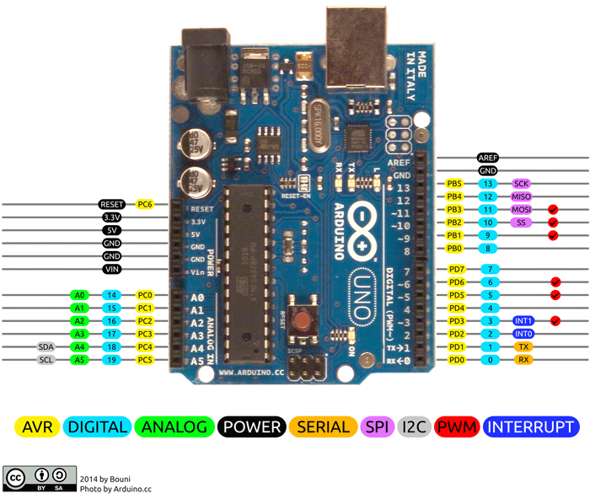

Fig: Arduino Uno board pin diagram

Arduino is an open source computer hardware and software that designs single-board microcontrollers and microcontroller kits for building digital devices and interactive objects that can sense and control objects in the physical and digital world. The project's products are distributed as open-sourc**e hardware and software**, which are licensed under the GNU Lesser General Public

License (LGPL). Arduino boards are available commercially in preassembled form or by designing the kits with respect to different application.

The different types of Arduino Uno are Arduino Nano, Arduino Pro Mini, Arduino Mega, Arduino Due, and Arduino Leonardo.

**PIN DESCRIPTION**

Table 5.2.1 explains the pin description Arduino Uno board.

Table 5.2.1: The pin description Arduino Uno board.

|  |  |  |
| --- | --- | --- |
| **Pin Category** | **Pin Name** | **Details** |
| Power | Vin, 3.3V, 5V, GND | Vin: Input voltage to Arduino when using an external power source.  5V: Regulated power supply used to power microcontroller and other components on the board.  3.3V: 3.3V supply generated by on-board voltage regulator. Maximum current draw is 50mA.  GND: ground pins. |
| Reset | Reset | Resets the microcontroller. |
| Analog Pins | A0 – A5 | Used to provide analog input in the range of 0-5V |
| Input/output Pins | Digital Pins 0 - 13 | Can be used as input or output pins. |
| Serial | 0(Rx), 1(Tx) | Used to receive and transmit TTL serial data. |
| External Interrupts | 2, 3 | To trigger an interrupt. |
| PWM | 3, 5, 6, 9, 11 | Provides 8-bit PWM output. |
| SPI | 10 (SS), 11 (MOSI), 12 (MISO) and 13 (SCK) | Used for SPI communication. |
| SPI | 10 (SS), 11 (MOSI), 12 (MISO) and 13 (SCK) | Used for SPI communication. |
| Inbuilt LED | 13 | To turn on the inbuilt LED. |
| TWI | A4 (SDA), A5 (SCA) | Used for TWI communication. |
| AREF | AREF | To provide reference voltage for input voltage. |

Table 5.2.1 Pin description

**ARDUINO UNO TECHNICAL SPECIFICATION**

Table 5.2.2: Explains the Arduino Uno technical specification.

Table 5.2.2: Arduino Uno technical specification

|  |  |
| --- | --- |
| Microcontroller | [ATmega328P](https://components101.com/microcontrollers/atmega328p-pinout-features-datasheet) – 8bit AVR family microcontroller |
| Operating Voltage | 5V |
| Recommended Input Voltage | 7-12V |
| Input Voltage Limits | 6-20V |
| Analog Input Pins | 6 (A0 – A5) |
| Digital I/O Pins | 14 (Out of which 6 provide PWM output) |
| DC Current on I/O Pins | 40 mA |
| DC Current on 3.3V Pin | 50 mA |
| Flash Memory | 32 KB (0.5 KB is used for Bootloader) |
| SRAM | 2 KB |
| EEPROM | 1 KB |
| Frequency (Clock Speed) | 16 MHz |

Table5.2.2 Pin Specification

**OVERVIEW**

Arduino Uno is a microcontroller board based on 8-bit ATmega328P microcontroller. Along with ATmega328P, it consists other components such as crystal oscillator, serial communication, voltage regulator, etc. to support the microcontroller. Arduino Uno has 14 digital input/output pins (out of which 6 can be used as PWM outputs), 6 analog input pins, a USB connection, A Power barrel jack, an ICSP header and a reset button.

**HOW TO USE AURDINO BOARD**

The 14-digital input/output pins can be used as input or output pins by using pin Mode (), digital Read () and digital Write () functions in Arduino programming. Each pin operates at 5V and can provide or receive a maximum of 40mA current and has an internal pull-up resistor of 20-50 K Ohms which are disconnected by default.  Out of these 14 pins, some pins have specific functions as listed below:

1. **Serial Pins 0 (Rx) and 1 (Tx):** Rx and Tx pins are used to receive and transmit TTL serial data. They are connected with the corresponding ATmega328P USB to TTL serial chip.
2. **External Interrupt Pins 2 and 3:** These pins can be configured to trigger an interrupt on a low value, a rising or falling edge, or a change in value.
3. **PWM Pins 3, 5, 6, 9 and 11:** These pins provide an 8-bit PWM output by using analog Write () function.
4. **SPI Pins 10 (SS), 11 (MOSI), 12 (MISO) and 13 (SCK):** These pins are used for SPI communication.
5. **In-built LED Pin 13:** This pin is connected with built-in LED. When pin 13 is high, then LED will ON and when 13 pin is low, it represents led is OFF.

There are 14digital pins and 6 analog input pins, each of which provides 10 bits of resolution, that is 1024 different values. They measure from 0 to 5 volts but this limit can be increased by using AREF pin with analog reference () function.

Analog pin 4 Serial Data Access (SDA) and pin 5 scratch controlling Arduino (SCA) also used for TWI communication using wire library. Arduino Uno has a couple of other pins as explained below:

1. **AREF:** Used to provide reference voltage for analog inputs with analog Reference () function.
2. **Reset Pin:**Making this pin LOW, resets the microcontroller.

**COMMUNICATION**

Arduino can be used to communicate with a computer, another Arduino board or other microcontrollers. The ATmega328P microcontroller provides UART TTL (5V) serial communication which can be done using digital pin 0 (Rx) and digital pin 1 (Tx). An ATmega16U2 on the board channels this serial communication over USB and appears as a virtual com port to software on the computer. The ATmega16U2 firmware uses the standard USB COM drivers, and no external driver is needed. However, on Windows, a in file is required. The Arduino software includes a serial monitor which allows simple textual data to be sent to and from the Arduino board. There are two RX and TX LEDs on the Arduino board which will flash when data is being transmitted via the USB-to-serial chip and USB connection to the computer (not for serial communication on pins 0 and 1). A Software Serial library allows for serial communication on any of the Uno's digital pins. The ATmega328P also supports I2C (TWI) and SPI communication. The Arduino software includes a Wire library to simplify use of the I2C bus.

**ARDUINO UNO TO ATMEGA328 PIN MAPPING**

When ATmega328 chip is used in place of Arduino Uno, or vice versa, the image below shows the pin mapping between the two.

**SOFTWARE**

Arduino IDE (Integrated Development Environment) is required to program the Arduino Uno board.

**ARDUINO PROGRAMMING**

Once Arduino IDE is installed on the computer, connect the board with computer using USB cable. Now open the Arduino IDE and choose the correct board by selecting Tools>Boards>Arduino/Genuine Uno and choose the correct Port by selecting Tools>Port. Arduino Uno is programmed using Arduino programming language based on Wiring. To get it started with Arduino Uno board and blink the built-in LED, load the example code by selecting Files>Examples>Basics>Blink. Once the example code (also shown below) is loaded into the IDE, click on the ‘upload’ button given on the top bar. Once the upload is finished, it should see the Arduino’s built-in LED blinking.  Below is the example code for blinking.

// the setup function runs once it press reset or power the board

void setup () {

// initialize digital pin LED_BUILTIN as an output.

pin Mode (LED_BUILTIN, OUTPUT);

}

// the loop function runs over and over again forever

void loop () {

digital Write (LED_BUILTIN, HIGH); // turn the LED on (HIGH is the voltage level)

delay (1000); // wait for a second

digital Write (LED_BUILTIN, LOW); // turn the LED off by making the voltage LOW

delay(1000); // wait for a second

}

**APPLICATIONS**

1. Prototyping of Electronics Products and Systems
2. Multiple DIY Projects.
3. Easy to use for beginner level DIY and makers.
4. Projects requiring Multiple I/O interfaces and communications.

**ARDUINO UNO 2D MODEL**

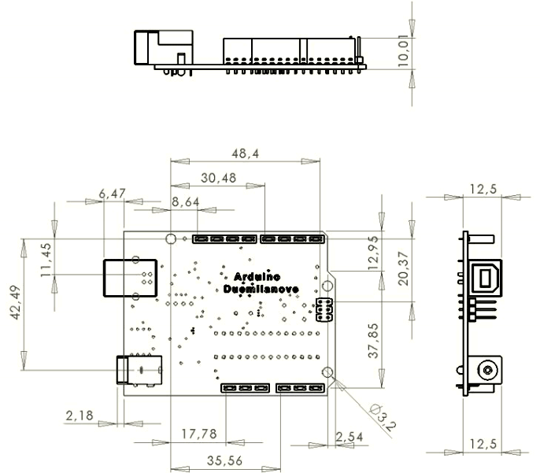

Fig**:** Arduino Uno 2D Model

**Module 2: LCD**

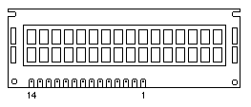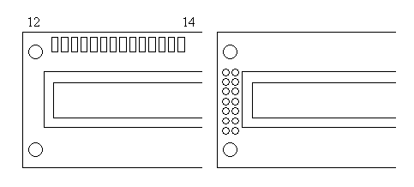

Fig: Sample LCD Display

LCD (Liquid Crystal Display) is a type of flat panel display which uses liquid crystals in its primary form of operation. LEDs have a large and varying set of use cases for consumers and businesses, as they can be commonly found in smartphones, televisions, computer monitors and instrument panels.

LCDs were a big leap in terms of the technology they replaced, which include light-emitting diode (LED) and gas-plasma displays. LCDs allowed displays to be much thinner than cathode ray tube ([CRT](https://www.techtarget.com/whatis/definition/cathode-ray-tube-CRT)) technology. LCDs consume much less power than LED and gas-display displays because they work on the principle of blocking light rather than emitting it. Where an LED emits light, the liquid crystals in an LCD produces an image using a backlight. As LCDs have replaced older display technologies, LCDs have begun being replaced by new display technologies such as OLEDs.

In recent years the LCD is finding widespread use replacing LEDs (seven segment LEDs or other multi-segment LEDs). This is due to the following reasons:

1. The declining prices of LDCs.
2. The ability to display numbers, characters, and graphics. This is in contrast to LEDs, which are limited to numbers and a few characters.
3. Incorporation of a refreshing controller into the LDC, thereby relieving the CPU of the task of refreshing the LCD. In contrast, the LED must be refreshed by the CPU (or in some other way) to keep displaying the data.
4. Ease of programming for characters and graphics.

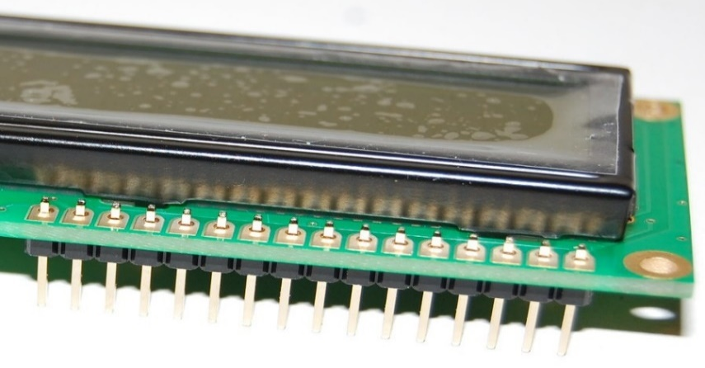

Fig: LCD Sensor

**LCD pin descriptions:**

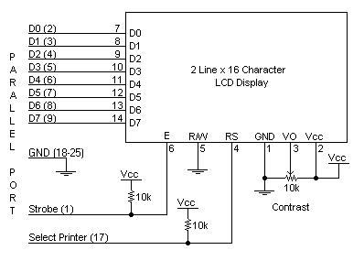

The LCD discussed in this section has 14 pins. The function of each pin is given in Table 5.2.1 Figure 5.2.3 shows the pin positions for various sample LCDs.

**VCC, VSS, and VEE:**

While VCC and VSS provide +5V and ground, respectively, VEE is used for controlling LCD contrast. RS, register select. There are two very important registers

Inside the LCD. The RS pin is used for their selection as follows. If RS=0, the instruction command code register is selected, allowing the user to send a command such as clear display, cursor at home, etc. IF RS=1 the data register is selected, allowing the user to send data to be displayed on the LCD.

**R/W (read/write):**

R/W input allows the user to write information to the LCD or read information from it. R/W=1 when reading; R/W=0 when writing.

**E(enable):**

The enable pin is used by the LCD to latch information presented to its data pins. When data is supplied to data pins, a high-to-low pulse must be applied to this pin in order for the LCD to latch in the data present at the data pins. This pulse must be a minimum of 450 ns wide.

**D0 - D7:**

The 8-bit data pins, D0 - D7, are used to send information to the LCD or read the contents of the LCD’s internal registers.

To display letters and numbers, we send ASCII codes for the letters A - Z, a - z, and numbers 0 - 9 to these pins while making RS=1.

There are also instruction command codes that can be sent to the LCD to clear the display or force the cursor to the home position or blink the cursor. Table 11.2 lists the instruction command codes.

We also use RS = 0 to check the busy flag bit to see if the LCD is ready to receive information. The busy flag is D7 and can be read when R/W=1 and RS = 0, as follows: if R/W = 1, RS = 0. When D7 = 1 (busy flag = 1), the LCD is busy taking care of internal operations and will not accept any new information. When D7 = 0, the LCD is ready to receive new information. Note: It is recommended to check the busy flag before writing any data to the LCD.

**Table: Pin Descriptions for LCD:**

Pin Symbol I/O Description

1 VSS -- Ground

2 VCC -- +5V power supply

3 VEE -- Power supply to control contrast

4 RS I -- RS=0 to select command register,

RS=1 to select data register

5 R/W I R/w-0 for write, R/W=1 for read

6 E I/O Enable

7 DB0 I/O The 8-bit data bus

8 DB1 I/O The 8-bit data bus

9 DB2 I/O The 8-bit data bus

10 DB3 I/O The 8-bit data bus

11 DB4 I/O The 8-bit data bus

12 DB5 I/O The 8-bit data bus

13 DB6 I/O The 8-bit data bus

14 DB7 I/O The 8-bit data bus

Table: Pin Descriptions for LCD

**Table: LCD Command Codes:**

Code Command to LCD Instruction [5]

(Hex) Register

1 Clear display screen

2 Return home

4 Decrement cursor (shift cursor to left)

5 Shift display right

6 Increment cursor (shift cursor to right)

7 Shift display left

8 Display off, cursor off

A Display off, cursor on

C Display on, cursor off

E Display on, cursor blinking

F Display on, cursor blinking

10 Shift cursor position to left

14 Shift cursor position to right

18 Shift the entire display to the left

1C Shift the entire display to the right

80 Force cursor to beginning of 1st line

C0 Force cursor to beginning of 1st line

38 2 lines and 5x7 matrix

# Module 3: LDR

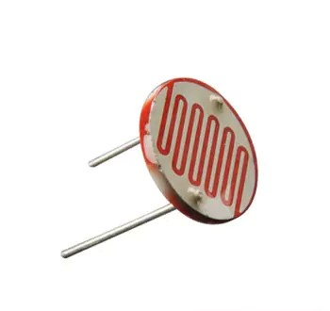

Fig: LDR Sensor

LDR or Light Dependent Resistors are very useful especially in light/dark sensor circuits. These help in automatically switching ON /OFF the street lights and etc., normally the resistance of an LDR is very high, sometimes as very high as 1000000 ohms, but when they are illuminated with light, resistance drop dramatically. Electronic up to sensors are the devices that alter their electrical characteristics, in the presence of visible or invisible light. The best-known devices of these types are the light dependent resistor (LDR), the photo diode and the phototransistors.

**LDR Working Principle**

It works on the principle of photoconductivity whenever the light falls on its photoconductive material, it absorbs its energy and the electrons of that photoconductive material in the valence band get excited and go to the conduction band and thus increasing the conductivity as per the increase in light intensity. Also, the energy in incident light should be greater than the bandgap gap energy so that the electrons from the valence band got excited and go to the conduction band. he LDR has the highest resistance in dark around 1012 Ohm and this resistance decreases with the increase in Light.

### **Light Intensity V/S Resistance**

As per the property of LDRs, the amount of light entering the LDR the inversely proportional to the resistance of the sensor, and the graph is hyperbolic in nature.

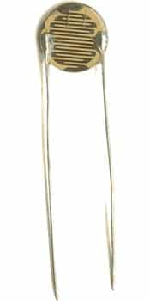

Fig: Light Dependent Resistor

**LDR Applications**

* The photoresistor is generally used in detecting the presence and intensity of light
* Used in automatic lights that switch on and off according to light
* [Simple Smoke Detector](https://www.electronicsforu.com/electronics-projects/simple-smoke-detector) Alarm, Clock with automatic light
* Optical circuit design
* Photo proximity switch
* Laser-based security systems
* Solar Street Lamps
* Camera light meters
* Clock radios
* Can be used in Dynamic Compressors, some compressors use LDR and LED connected to the signal source to create changes in signal gain.

**Module 4: Relays**

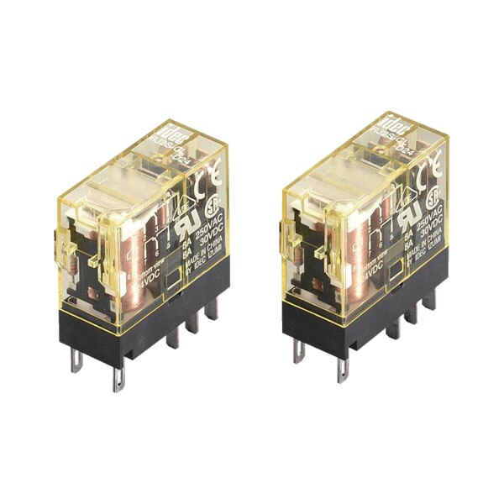

Fig: Relays

## **A relay is an electronically operated switch that is remotely activated by an electromagnet which pulls a set of contacts to either make or break a circuit.** Electrical relays are commonly used for switching signals, radio frequencies, high current circuits when using a lower current circuit, and loads such as resistive, motor, lamp, inductive, and capacitive applications. This is helpful when an in-line switch or existing circuit does not have the capacity to handle the required current.

Relays are normally used in the control panels, manufacturing, and building automation to control the power along with switching the smaller current values in a control circuit. However, the supply of amplifying effect can help control the large amperes and voltages because if low voltage is applied to the relay coil, a large voltage can be switched by the contacts.

If preventive relays are being used, they can detect overcurrent, overload, undercurrent, and reverse current to ensure the protection of electronic equipment. Last but not least; it is used to heat the elements, switch on audible alarms, switch the starting coils, and pilot the lights.

For example, when you push the button on a TV remote to watch TV, it sends an electrical signal to the “relay” inside the TV, turning the main power ON. There are various types of relays used in many applications to control different amounts of currents and number of circuits.

## **How Relay Works?**

* Relay works on the principle of electromagnetic induction.
* When the electromagnet is applied with some current, it induces a magnetic field around it.
* Above image shows working of the relay. A switch is used to apply DC current to the load.
* In the relay, Copper coil and the iron core acts as electromagnet.
* When the coil is applied with DC current, it starts attracting the contact as shown. This is called energizing of relay.
* When the supply is removed it retrieves back to the original position. This is called De energizing of relay.

There are also such relays, whose contacts are initially closed and opened when there is supply i.e. exactly to opposite to the above shown relay. Solid state relays will have sensing element to sense the input voltage and switches the output using opto-coupling.

**Module 5: Temperature Sensor**

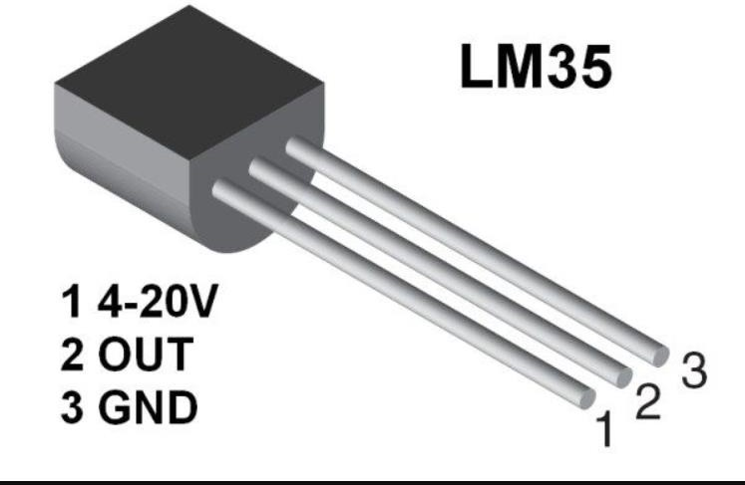

# Fig: Temperator sensor

# Temperature sensor is a device which is designed specifically to measure the hotness or coldness of an object. LM35 is a precision IC temperature sensor with its output proportional to the temperature (in °C). With LM35, the temperature can be measured more accurately than with a thermistor. It also possesses low self-heating and does not cause more than 0.1 °C temperature rise in still air. The operating temperature range is from -55°C to 150°C.The LM35’s low output impedance, linear output, and precise inherent calibration make interfacing to readout or control circuitry especially easy.

### **How Temperature Sensors Work?**

The working principle of a temperature sensor is the voltage across the terminals of the diode. If there is an increase in the voltage, the temperature also increases. This is followed by a drop in the voltage between the terminals of the transistor of base and emitter in a diode. There are also temperature sensors that work on the principle of stress change caused by changes in temperature.

In a vibrating wire temperature meter, dissimilar metals have different linear coefficients of expansion. It mainly consists of a magnetic stretched wire of high tensile strength with two ends fixed to any dissimilar metal so that any temperature change will directly affect the tension in the wire and its natural vibration frequency.

The dissimilar metal can be made from aluminium since it has a larger linear expansion coefficient than steel. When the conversion of the temperature signal into frequency occurs, the very same read-out unit that is used for other vibrating wire sensors can also be utilized in the monitoring of temperature also.

The specially built vibrating wire sensor is the one that senses the temperature change and then the temperature change is converted into an electrical signal which is then transmitted to the read out the unit as a frequency.

### **Temperature Sensor Components**

There are three types of components in temperature sensors. There are essential components of a temperature sensor including [thermocouple](https://www.iqsdirectory.com/articles/thermocouple.html) or extension cables and wires, as well as the

sensing elements. The following are examples of components which complete the sensor: insulating beads, connectors, connecting heads, and protecting tubes. There are also associated components that are necessary in the use of sensors like converters and controllers.

#### **Module 6: Arduino IDE**

The [Arduino](https://en.wikipedia.org/wiki/Arduino) integrated development environment ([IDE](https://en.wikipedia.org/wiki/Integrated_development_environment)) (figure 4.4.1) is a [cross-platform](https://en.wikipedia.org/wiki/Cross-platform) application for [Windows](https://en.wikipedia.org/wiki/Windows), [macOS](https://en.wikipedia.org/wiki/MacOS), [Linux](https://en.wikipedia.org/wiki/Linux) that is written in the programming language [Java](https://en.wikipedia.org/wiki/Java_(programming_language)). It is used to write and upload programs to Arduino compatible boards, but also, with the help of 3rd party cores, other vendor development boards. The Arduino IDE supports the languages [C](https://en.wikipedia.org/wiki/C_(programming_language)) and [C++](https://en.wikipedia.org/wiki/C%2B%2B) using special rules of code structuring. It is an official Arduino software, making code compilation too easy that even a common person with no prior technical knowledge can get their feet wet with the learning process. The main code, also known as a sketch, created on the IDE platform will ultimately generate a Hex File which is then transferred and uploaded in the controller on the board. The main code, also known as a sketch, created on the IDE platform will ultimately generate a Hex File which is then transferred and uploaded in the controller on the board.

The IDE environment is mainly distributed into three sections:

* Menu Bar
* Text Editor
* Output Pane

#### 

Fig: Arduino IDE

#### **Embedded C**

Embedded C is an extension to C programming language that provides support for developing efficient programs for embedded devices. It is not a part of the C language. C is the most widely used programming language for embedded processors/controllers. Assembly is also used but mainly to implement those portions of the code where very high timing accuracy, code size efficiency, etc. are prime requirements.

Arduino IDE (Integrated development Environment) is fully developed into functionality of full of libraries, as long as programming the Arduino UNO in Embedded C language is possible because Arduino IDE can compile both Arduino code as well as AVR standard code.

* When designing software for a smaller embedded system with the 8051, it is very common place to develop the entire product using assembly code. With many projects, this is a feasible approach since the amount of code that must be generated is typically less than 8 kilobytes and is relatively simple in nature. If a hardware engineer is tasked with designing both the hardware and the software, he or she will frequently be tempted to write the software in assembly language.
* The trouble with projects done with assembly code can is that they can be difficult to read and maintain, especially if they are not well commented. Additionally, the amount of code reusable from a typical assembly language project is usually very low. Use of a higher-level language like C can directly address these issues. A program written in C is easier to read than an assembly program.
* Since a C program possesses greater structure, it is easier to understand and maintain. Because of its modularity, a C program can better lend itself to reuse of code from project to project. The division of code into functions will force better structure of the software and lead to functions that can be taken from one project and used in another, thus reducing

overall development time. A high order language such as C allows a developer to write code, which resembles a human’s thought process more closely than does the equivalent assembly code. The developer can focus more time on designing the algorithms of the system rather than having to concentrate on their individual implementation. This will greatly reduce development time and lower debugging time since the code is more understandable.

* By using a language like C, the programmer does not have to be intimately familiar with the architecture of the processor. This means that someone new to a given processor can get a project up and running quicker, since the internals and organization of the target processor do not have to be learned. Additionally, code developed in C will be more portable to other systems than code developed in assembly. Many target processors have C compilers available, which support ANSI C.
* All of this is not to say that assembly language does not have its place. In fact, many embedded systems (particularly real time systems) have a combination of C and assembly code. For time critical operations, assembly code is frequently the only way to go. One of the great things about the C language is that it allows you to perform low-level manipulations of the hardware if need be, yet provides you the functionality and abstraction of a higher order language.

# CHAPTER 6

**SYSTEM DESIGN**

* 1. **Requirement Analysis**

**HARDWARE AND SOFTWARE REQUIREMENTS:**

**Hardware Requirements:**

* Arduino/ESP32
* LCD Display
* IR Sensor
* LDR
* Temperature Sensor
* Relay
* Fan
* Bulb
* Power Supply

**Software Requirements**:

* Arduino IDE
* EmbeddedC
  1. **Data Flow Diagram**

Data Flow diagram depicts the relationships between the main components involved in the classroom automation system:

1. **Arduino:** Represents the microcontroller responsible for reading data from sensors (LDR and temperature sensor) and controlling relays based on the data.
2. **LDR:** Represents the light sensor responsible for measuring light intensity in the classroom.
3. **Temperature Sensor:** Represents the temperature sensor responsible for measuring the temperature in the classroom.
4. **Relays:** Represents the component used for controlling devices like lights and HVAC systems.

**Level 0:**

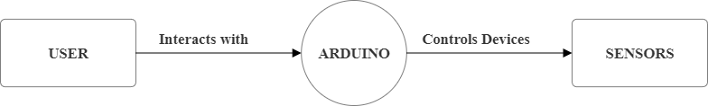

Fig. 2 Data Flow Diagram (Level 0)

In this data flow diagram, firstly the user interacts with the Arduino (microcontroller), by turning it ON/OFF. Later Arduino controls devices such as sensors for better communication.

**Level 1:**

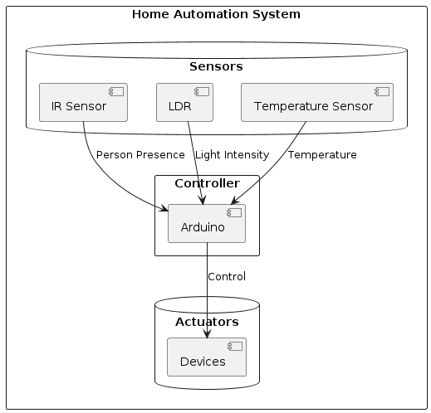

Fig. 3 Data Flow Diagram (Level 1)

In this data flow diagram, the sensors such as IR Sensor, LDR Sensor, Temperature Sensor works based on the commands sent by Arduino. IR Sensor detects the presence of a person in the classroom, if any person is detected it sends signal to Arduino. LDR detects light intensity of the classroom and sends the result for the Arduino. Temperature Sensor detects the temperature of the classroom and sends whether the temperature is hot or humid etc for the Arduino. Based on these inputs given by the sensors Arduino controls devices.

**Level 2:**

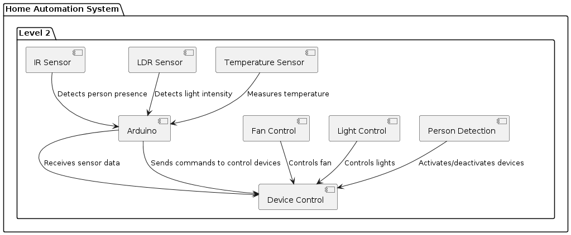

Fig. 4 Data Flow Diagram (Level 3)

In this dataflow diagram, based on the inputs gained from sensors in the level1, the Arduino controls devices such as fans, lights, etc. Arduino receives sensor data and send commands to control devices. Based on the input data from temperature sensor the speed of the fan is automated. Likely based on the input data from LDR sensor the intensity of the lights is automated. Detection of person in the classroom data from IR sensor makes Arduino activates/deactivates the devices.

* 1. **Use case diagram**

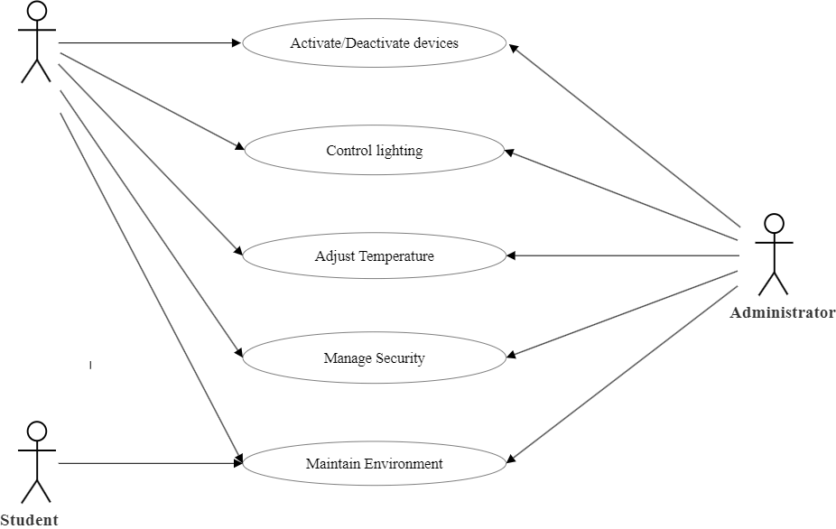

# Fig. 5 Use case Diagram

# This diagram illustrates the interactions between the actors (Teacher, Administrator, and Student) and the use cases related to monitoring the environment, controlling lighting, adjusting temperature, managing security, and activating/deactivating devices in the classroom automation system. The components such as Arduino, LDR, temperature sensor, and relays are depicted as part of the system's internal operations.

# CHAPTER 7

**CODING**

#include <LiquidCrystal.h>

LiquidCrystal lcd(13,12,11,10,9,8);

#include <DHT.h>

#define dht_pin 4

#define Type DHT11

DHT HT(dht_pin,Type);

float T;

int light=2;

int fan=3;

int ir=5;

int ldr=A0;

void setup() {

lcd.begin(16,2);

Serial.begin(9600);

HT.begin();

pinMode(light,OUTPUT);

pinMode(fan,OUTPUT);

pinMode(ir,INPUT);

pinMode(ldr,INPUT);

lcd.clear();

lcd.print("SMART CLASS");

lcd.setCursor(0,1);

lcd.print("AUTOMATION..");

delay(1000);

}

void loop() {

T=HT.readTemperature();

Serial.println("T="+String(T));

lcd.clear();

lcd.print("T="+String(T));

lcd.setCursor(0,1);

lcd.print("ldrval="+String(analogRead(ldr)));

delay(1000);

if(digitalRead(ir)==LOW)

{

lcd.clear();

lcd.print("STUDENT DETECTED");

delay(1000);

if(T>35.0)

{

digitalWrite(fan,HIGH);

delay(6000);

digitalWrite(fan,LOW);

}

int ldrval=analogRead(ldr);

Serial.println("ldrval="+String(ldrval));

delay(500);

if(ldrval>700)

{

digitalWrite(light,HIGH);

}

}

else

{

digitalWrite(light,LOW);

}

# CHAPTER 8

**TESTING**

* 1. **Types of Testing**
* **Unit Testing**

1. IR Sensor for Student Presence Detection
2. Test Case 1: Detect Presence

* Description: Verify that the IR sensor detects the presence of a student.
* Input: Simulated presence (e.g., a hand waved in front of the sensor).
* Expected Output: Presence detection signal is triggered.

1. Test Case 2: No Presence

* Description: Verify that the IR sensor correctly identifies no presence.
* Input: No movement in front of the sensor.
* Expected Output: No presence detection signal is triggered.

1. Temperature Sensor for Fan Control
   1. Test Case 1: High Temperature

* Description: Verify that the fan turns on when the temperature is above the threshold.
* Input: Simulated high temperature (e.g., above 30°C).
* Expected Output: Fan is turned on.
  1. Test Case 2: Low Temperature
* Description: Verify that the fan turns off when the temperature is below the threshold.
* Input: Simulated low temperature (e.g., below 25°C).
* Expected Output: Fan is turned off.

1. LDR for Light Switching
   1. Test Case 1: Low Light

* Description: Verify that the lights turn on when the ambient light level is low.
* Input: Simulated low light conditions.
* Expected Output: Lights are turned on.
  1. Test Case 2: High Light
* Description: Verify that the lights turn off when the ambient light level is high.
* Input: Simulated high light conditions.
  + Expected Output: Lights are turned off.
* **Integration Testing**

1. IR Sensor and Light Control
   * 1. Test Case 1: Presence Detection and Light On
   * Description: Verify that the lights turn on when a student is detected.
   * Input: Simulated presence in low light conditions.
   * Expected Output: Lights are turned on.
     1. Test Case 2: No Presence and Light Off
   * Description: Verify that the lights remain off when no student is detected.
   * Input: No presence in low light conditions.
   * Expected Output: Lights remain off.
2. Temperature Sensor and Fan Control
   1. Test Case 1: High Temperature and Fan On
   * Description: Verify that the fan turns on when the temperature exceeds the threshold.
   * Input: Simulated high temperature.
   * Expected Output: Fan is turned on.
   1. Test Case 2: Low Temperature and Fan Off
   * Description: Verify that the fan turns off when the temperature is below the threshold.
   * Input: Simulated low temperature.
   * Expected Output: Fan is turned off.
3. LDR and Light Control
   * 1. Test Case 1: Low Light and Light On

* Description: Verify that the lights turn on when the ambient light is low.
* Input: Simulated low light conditions.
* Expected Output: Lights are turned on.
  + 1. Test Case 2: High Light and Light Off
* Description: Verify that the lights turn off when the ambient light is high.
* Input: Simulated high light conditions.
* Expected Output: Lights are turned off.
* **System Testing**

Full System Test: Presence and Light Control

* + 1. Test Case 1: Entering Classroom
  + Description: Verify that the lights turn on when a student enters a dark classroom.
  + Input: Simulated presence detection and low ambient light.
  + Expected Output: Lights are turned on.
    1. Test Case 2: Leaving Classroom
  + Description: Verify that the lights turn off when no students are present in a dark classroom.
  + Input: No presence detection and low ambient light.
  + Expected Output: Lights are turned off.

Full System Test: Temperature and Fan Control

* + 1. Test Case 1: High Temperature
  + Description: Verify that the fan turns on when the classroom temperature is high.
  + Input: Simulated high temperature.
  + Expected Output: Fan is turned on.
    1. Test Case 2: Low Temperature
  + Description: Verify that the fan turns off when the classroom temperature is low.
  + Input: Simulated low temperature.
  + Expected Output: Fan is turned off.

Full System Test: Light Control

1. Test Case 1: Entering Classroom in Daylight
   * Description: Verify that the lights remain off when a student enters a well-lit classroom.
   * Input: Simulated presence detection and high ambient light.
   * Expected Output: Lights remain off.
2. Test Case 2: Classroom with Adequate Ambient Light
   * Description: Verify that the lights remain off when the ambient light is adequate regardless of presence.
   * Input: No presence detection and high ambient light.
   * Expected Output: Lights remain off.
   1. **Testing Results**

* **IR based motion detection**

- Performance Evaluation: Present the results of system testing, including energy savings, accuracy of student presence detection, and responsiveness of fan and light control.

- Analysis: Analyze the results, comparing them to the objectives and discussing any discrepancies or unexpected outcomes.

- User Feedback: If applicable, include feedback from teachers and students on the system's effectiveness and ease of use.

**Discussions**

The IR-based student presence detection system was tested in a controlled classroom environment to evaluate its effectiveness in detecting student presence and controlling the lights and fans accordingly. The following observations were made:

1. Detection Accuracy: The IR sensor accurately detected the presence of students within a range of 5 meters. The detection accuracy was consistent across different lighting conditions, including daylight and artificial lighting.

2. Response Time: The system demonstrated a quick response time of approximately 1-2

seconds for activating or deactivating the lights and fans upon detecting presence or absence, respectively.

3. Energy Savings: By ensuring that lights and fans were only operational when students were present, the system achieved significant energy savings. Preliminary measurements indicated a reduction in energy consumption by approximately 30% compared to manually controlled lights and fans.

The IR-based presence detection system proved to be an efficient method for automating classroom utilities. However, several factors need to be considered for optimal performance:

1. Sensor Placement: Proper placement of IR sensors is crucial. Sensors installed at the entrance and in strategic locations within the classroom ensured maximum coverage and minimized blind spots.

2. Sensitivity Adjustment: Adjusting the sensitivity of the IR sensors helped reduce false detections caused by minor movements or objects that were not students. Fine-tuning the sensitivity ensured that the system only responded to genuine presence.

3. Integration with Timers: To further enhance energy savings, integrating the presence detection system with timers could ensure that lights and fans turn off after a predefined period of inactivity. This would prevent scenarios where the system might remain active due to brief absences.

4. Multi-Sensor Integration: Combining IR sensors with other types of sensors (e.g., ultrasonic or PIR) could improve the overall accuracy of presence detection, especially in larger classrooms with more complex layouts.

* **Temperature Sensor-Based Fan Controlling**

The temperature sensor-based fan control system was tested over a range of temperatures to assess its responsiveness and accuracy in maintaining comfortable classroom conditions. The key results were as follows:

1. Temperature Range: The system was configured to activate the fan when the temperature exceeded 25°C and deactivate it when the temperature dropped below 22°C. This range provided a comfortable environment for students.

2. Response Time: The system showed a rapid response time of less than 5 seconds to changes in temperature, ensuring timely activation and deactivation of the fan.

3. Consistency: The temperature readings from the sensor were consistent with a deviation of less than 0.5°C, indicating reliable performance over extended periods.

**Discussions**

The temperature sensor-based fan control system successfully maintained a comfortable classroom environment, but several aspects warrant discussion:

1. Sensor Accuracy: The accuracy of the temperature sensor is critical. High-quality sensors with minimal drift over time should be used to ensure consistent performance. Calibration of the sensor at regular intervals can help maintain accuracy.

2. Fan Speed Control: Implementing a variable speed control mechanism for the fan, based on

temperature readings, could enhance comfort and reduce energy consumption. For instance, higher temperatures could trigger higher fan speeds, while moderate temperatures could operate the fan at lower speeds.

3. Integration with HVAC Systems: For classrooms equipped with HVAC systems, integrating the temperature sensor-based control with the HVAC system could provide a holistic approach to climate control, optimizing both heating and cooling functions.

4. User Override: Providing a manual override option allows teachers to adjust the fan settings based on specific needs or preferences, ensuring flexibility and user satisfaction.

* **LDR-Based Light Switching**

The LDR-based light switching system was evaluated to determine its effectiveness in controlling classroom lighting based on ambient light conditions. The main findings were:

1. Light Sensitivity: The LDR sensor accurately detected ambient light levels and switched the lights on or off accordingly. The threshold for switching was set to activate lights when ambient light dropped below 300 lux and deactivate when it exceeded 500 lux.

2. Response Time: The system exhibited an immediate response to changes in ambient light, with a response time of less than 2 seconds.

3. Energy Efficiency: By automatically adjusting lighting based on natural light availability, the system achieved considerable energy savings. Preliminary data indicated a reduction in energy usage by up to 40% during daytime operations.

**Discussions**

The LDR-based light switching system effectively automated classroom lighting, but certain factors should be considered to optimize performance:

1. Threshold Adjustment: Setting appropriate light thresholds is crucial. The chosen thresholds should balance between energy savings and maintaining adequate lighting levels for students. Regular adjustments may be necessary based on seasonal variations in natural light.

2. Sensor Placement: Proper placement of the LDR sensor is essential to avoid false readings due to localized light sources or shadows. Positioning the sensor to capture average ambient light levels across the classroom is recommended.

3. Combining with Presence Detection: Integrating the LDR-based system with the IR-based presence detection system can further enhance energy efficiency. Lights should only be activated when both the ambient light level is low, and students are present.

4. Gradual Dimming: Implementing a gradual dimming feature rather than abrupt on/off switching could improve comfort and reduce the sudden contrast in lighting, which can be disruptive in a learning environment.

# CONCLUSION AND FUTURE ENHANCEMENT

The deployment of IoT-based smart classroom automation systems marks a significant leap towards enhancing the educational environment. This project, incorporating IR-based student presence detection, temperature sensor-based fan control, and LDR-based light switching, demonstrates the vast potential of IoT technologies in creating more efficient, comfortable, and adaptive learning spaces. The integration of these technologies not only streamlines classroom management but also fosters an environment conducive to better learning outcomes. One of the primary benefits observed from the implementation of this system is the significant increase in energy efficiency. The LDR-based light switching mechanism ensures that lights are only in use when necessary, responding to the natural light available in the classroom. This automated control not only reduces electricity consumption but also extends the lifespan of lighting fixtures, leading to cost savings in the long run. Similarly, the temperature sensor-based fan control contributes to maintaining an optimal learning environment. By automatically adjusting the fan speed based on the ambient temperature, the system ensures that classrooms remain comfortable without the need for manual intervention. This not only enhances the comfort of students and teachers but also contributes to energy conservation, aligning with sustainable practices in educational institutions. The IR-based student presence detection system adds another layer of functionality by enabling intelligent control of classroom resources based on occupancy. This feature ensures that energy is not wasted in empty classrooms, as lights and fans are automatically turned off when no presence is detected. From a technological perspective, the integration of these IoT components showcases the versatility and scalability of smart systems. The use of microcontrollers and sensors demonstrates how relatively simple and cost-effective components can be combined to create sophisticated automation solutions. This modular approach allows for easy upgrades and expansions, making it possible to integrate additional functionalities as needed. The implementation of a central monitoring and control system further enhances the utility of the smart classroom. By providing real-time data and remote-control capabilities, administrators and teachers can manage classroom environments more effectively. This centralized system also enables the collection of data over time, which can be analyzed to identify usage patterns and further optimize resource management. However, the success of smart classroom automation also depends on addressing certain challenges. Ensuring the reliability and robustness of the system is crucial, as any technical failures could disrupt the learning process. Additionally, privacy concerns related to the use of presence detection technology must be addressed, ensuring that student data is handled with utmost care and security.

The impact of this automation on the learning experience is profound. By reducing the need for manual adjustments of environmental controls, teachers can focus more on delivering quality education. Students benefit from a consistently comfortable learning environment, which can enhance concentration and overall academic performance. This project underscores the role of technology in creating smarter, more responsive educational spaces. Moreover, the implementation of IoT in smart classrooms aligns with broader trends in digital transformation within education. As educational institutions increasingly embrace technology, projects like this serve as a model for how IoT can be leveraged to improve operational efficiency and educational outcomes. The lessons learned from this project can be applied to other educational settings, paving the way for widespread adoption of smart classroom technologies. In conclusion, the development and deployment of IoT-based smart classroom automation systems represent a significant advancement in educational technology. By enhancing energy efficiency, improving comfort, and streamlining classroom management, these systems contribute to creating better learning environments. As technology continues to evolve, the potential for further innovations in smart classrooms is vast, promising even greater benefits for students, teachers, and educational institutions as a whole.

**SCREENSHOTS**

**Adaptor connecting view:**

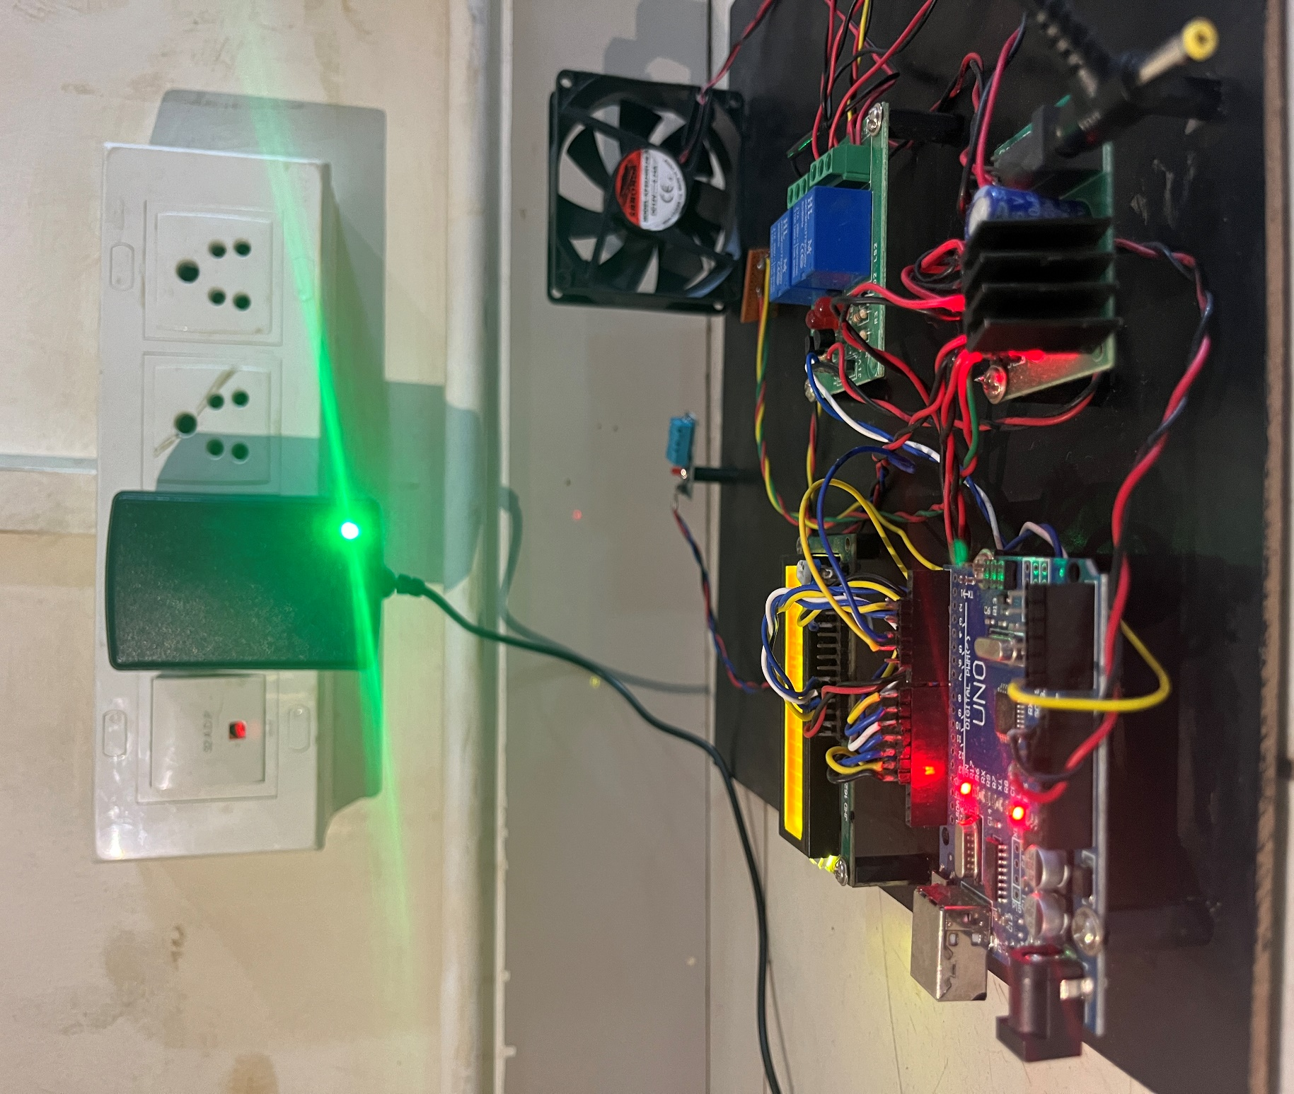

1. **Arduino IDE view:**

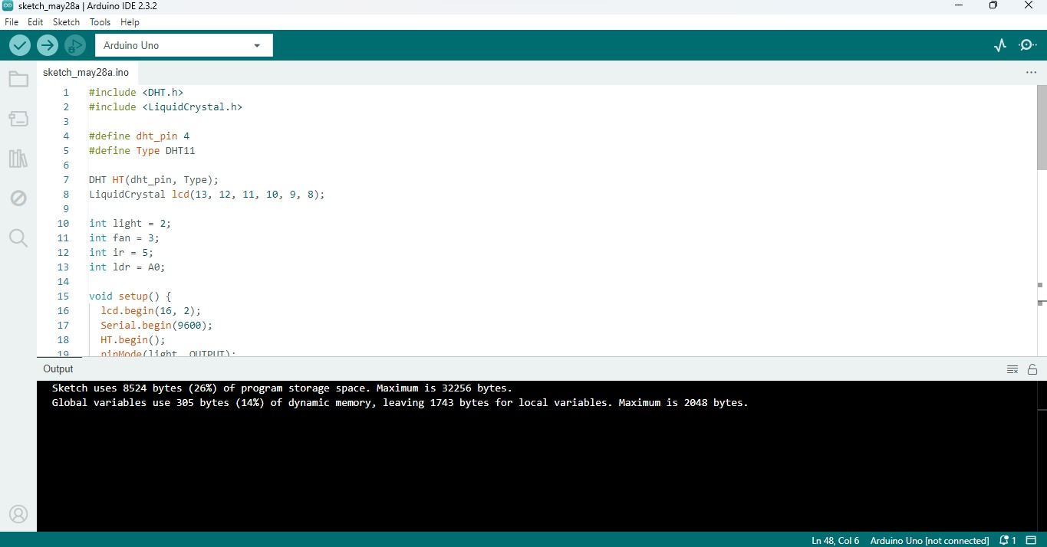

1. **Power supplied view:**

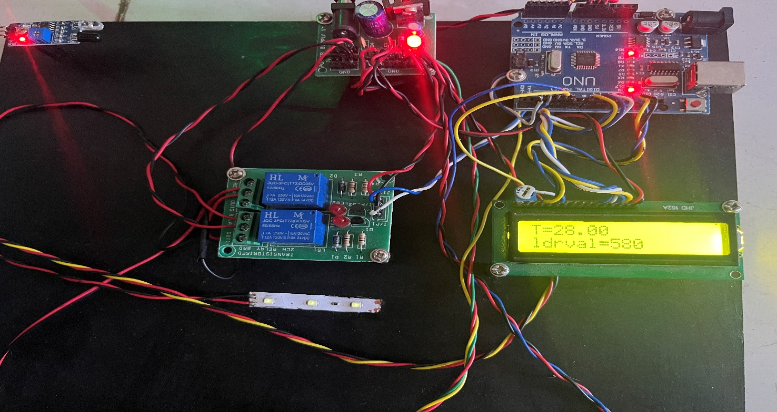

1. 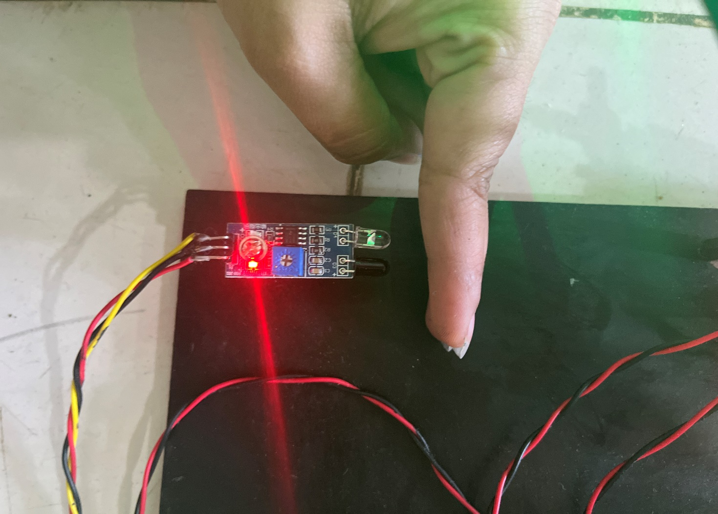**IR Sensor detection view:**

**IR sensor detection readings in the presence of Student view:**

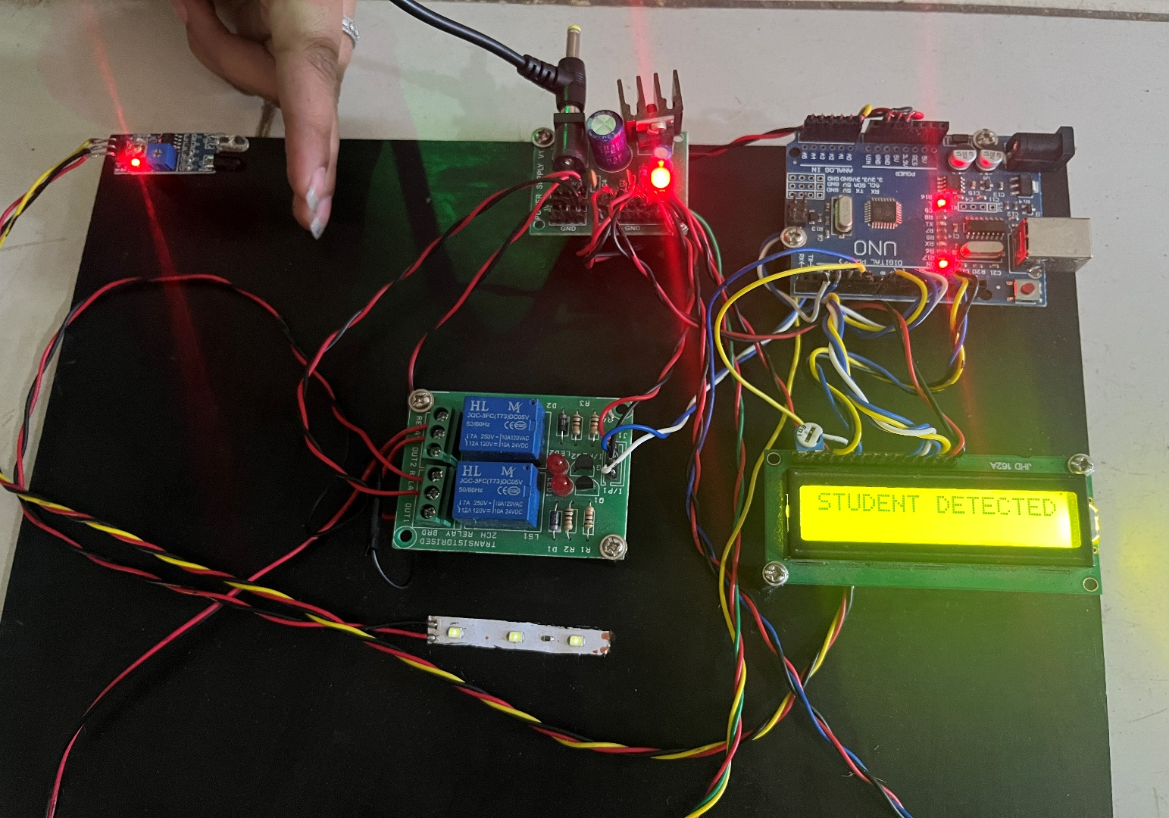

**IR sensor detection readings in the absence of Student view:**

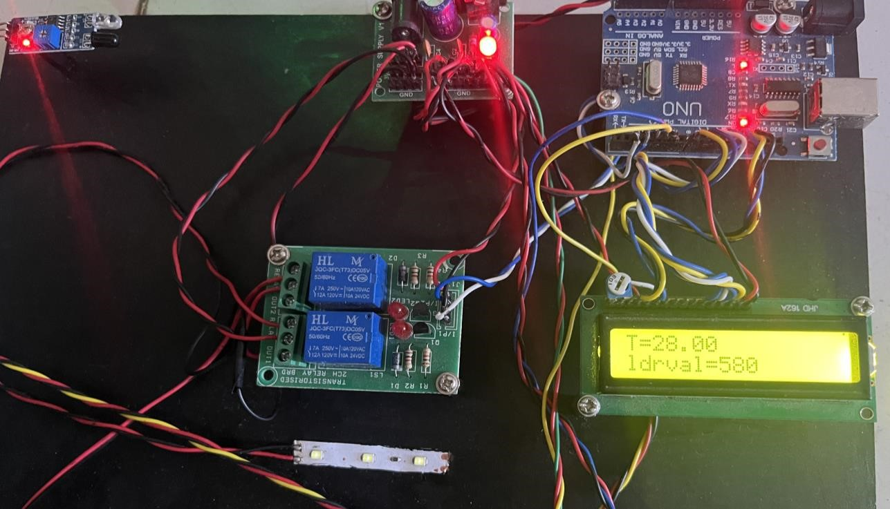

1. **LDR Sensor view:**

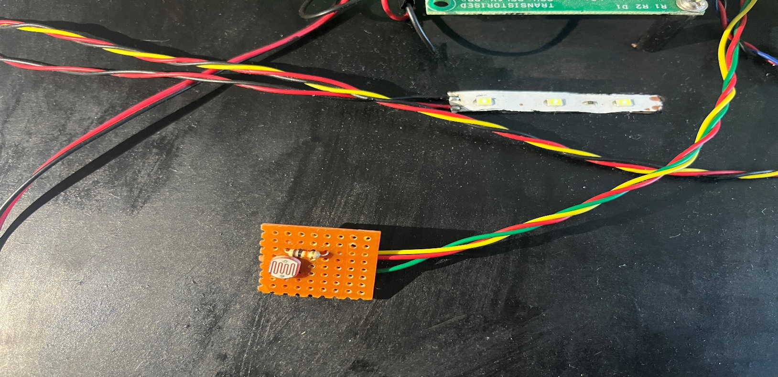

1. **LDR Sensor detection view:**

**Sensor output when the environment is bright:**

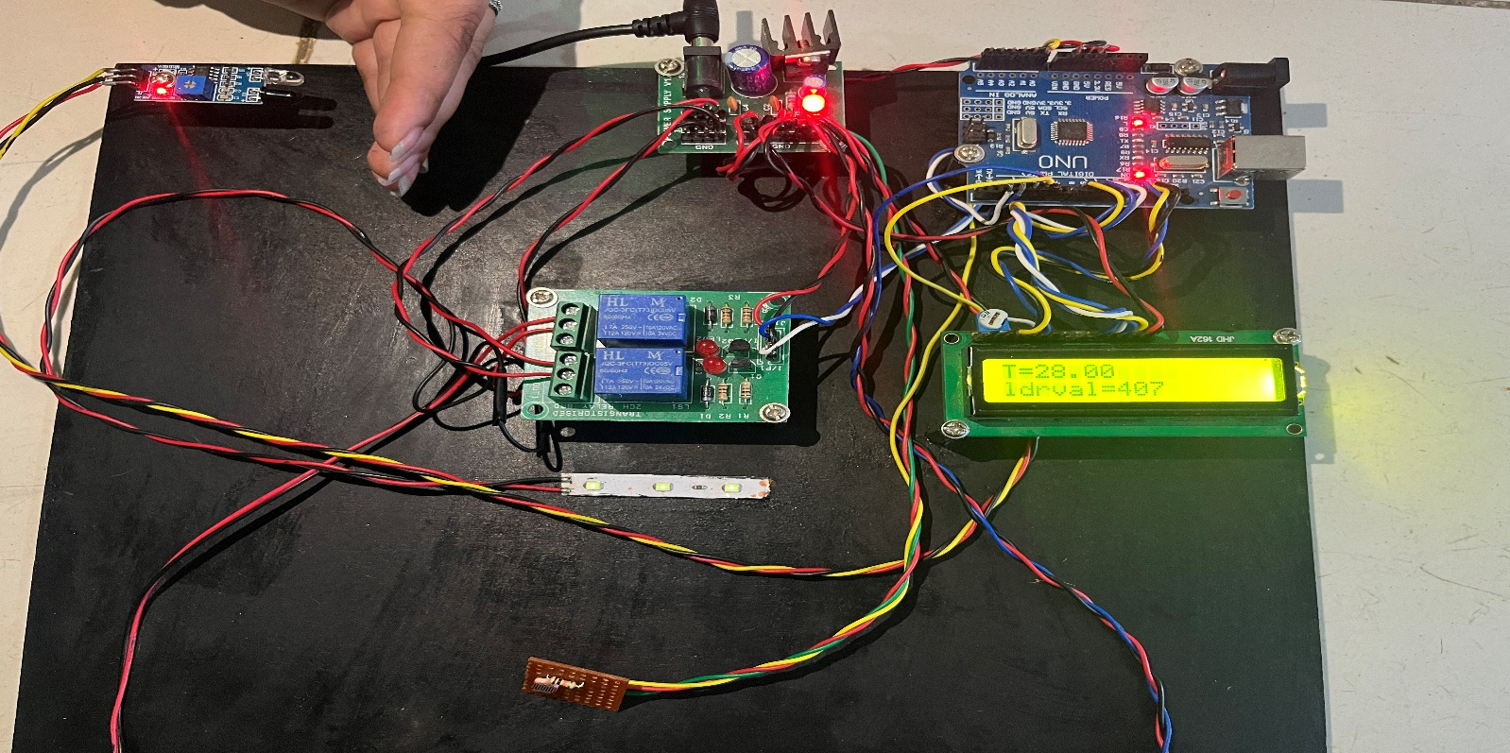

**Sensor output when the environment is dark:**

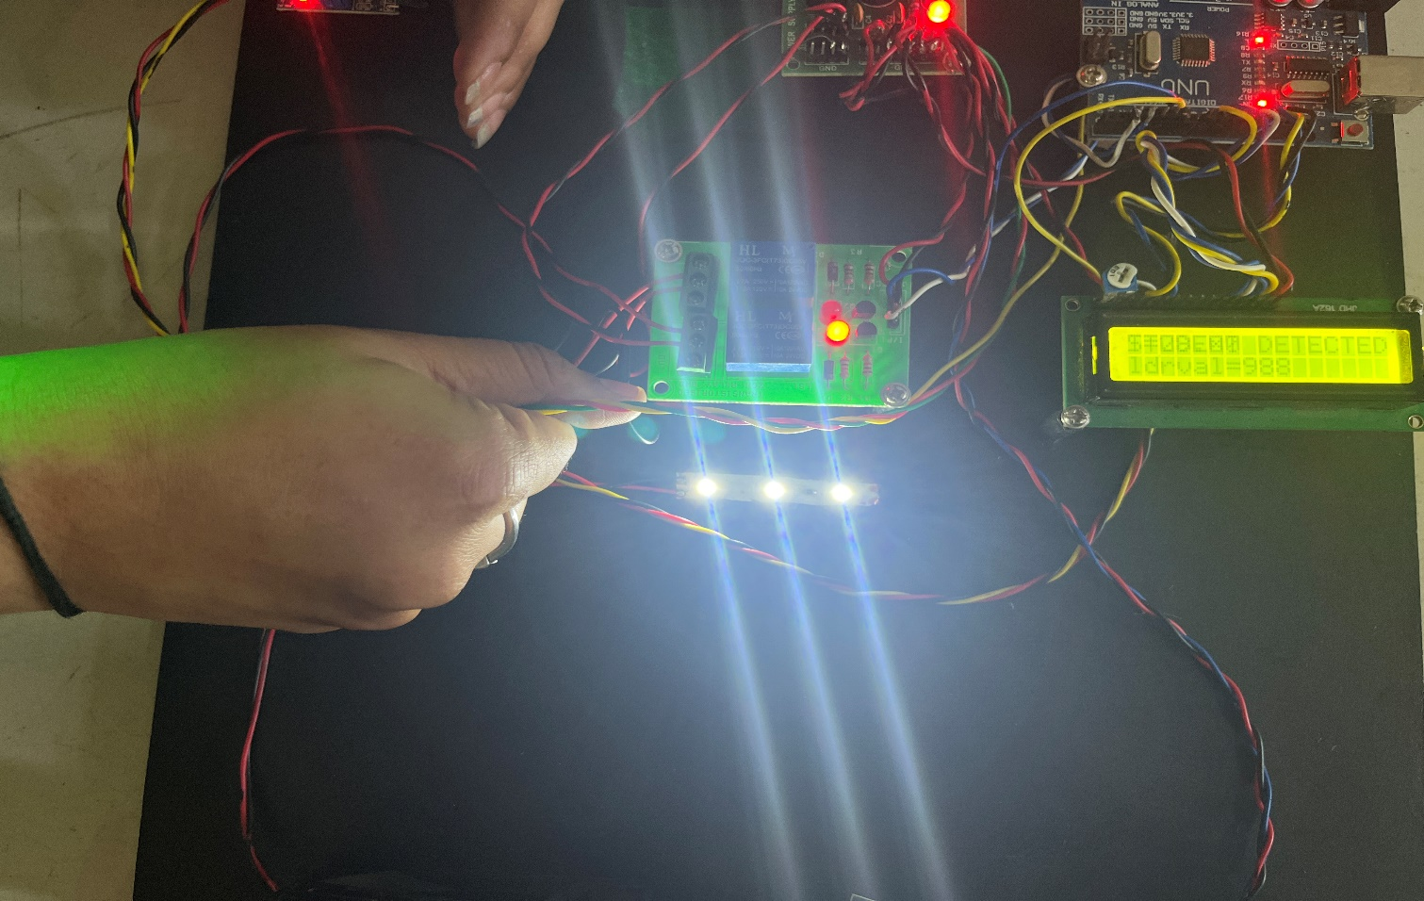

1. **Temperature Sensor view:**

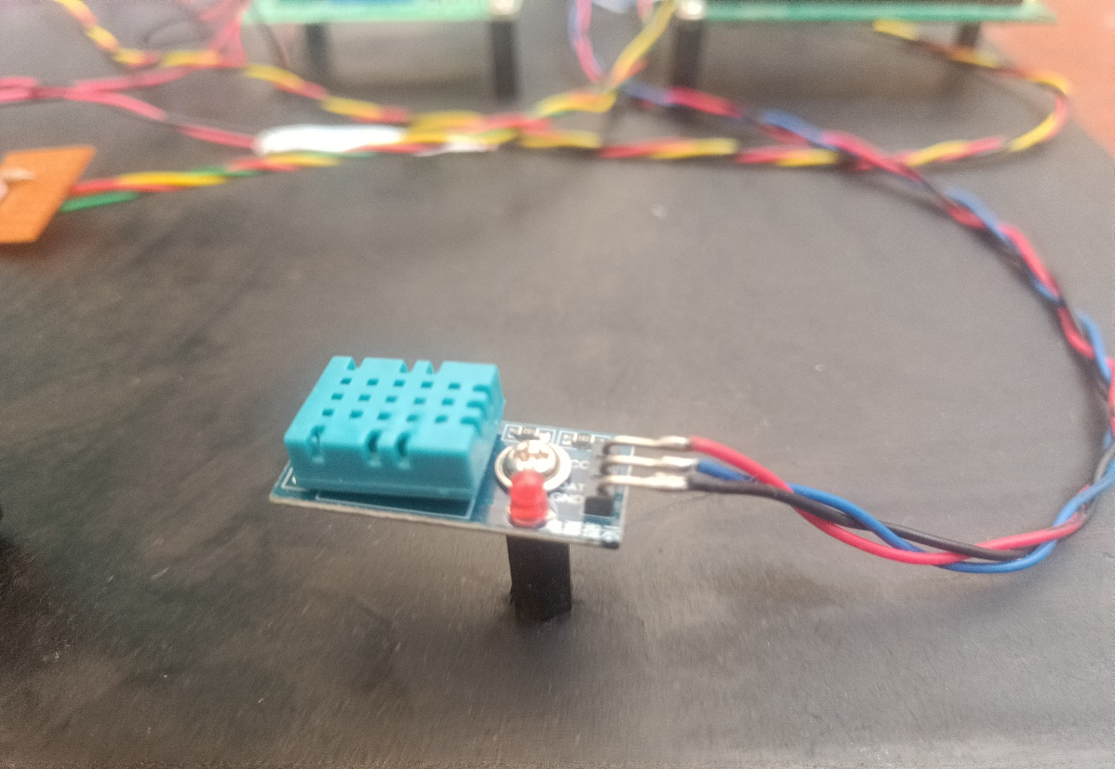

1. **Temperature readings view:**

**Temperature readings with normal temperature view:**

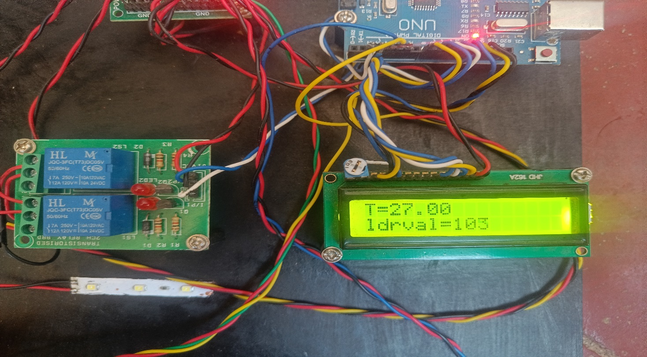

# Temperature readings with hot temperature view:

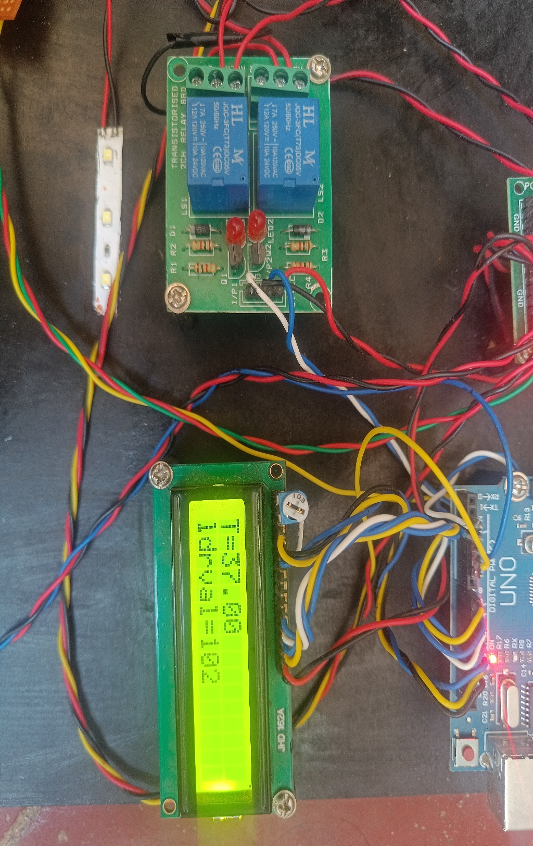

# Temperature sensor results view:

**Temperature sensor results when student not detected (fan doesn’t turn on) view:**

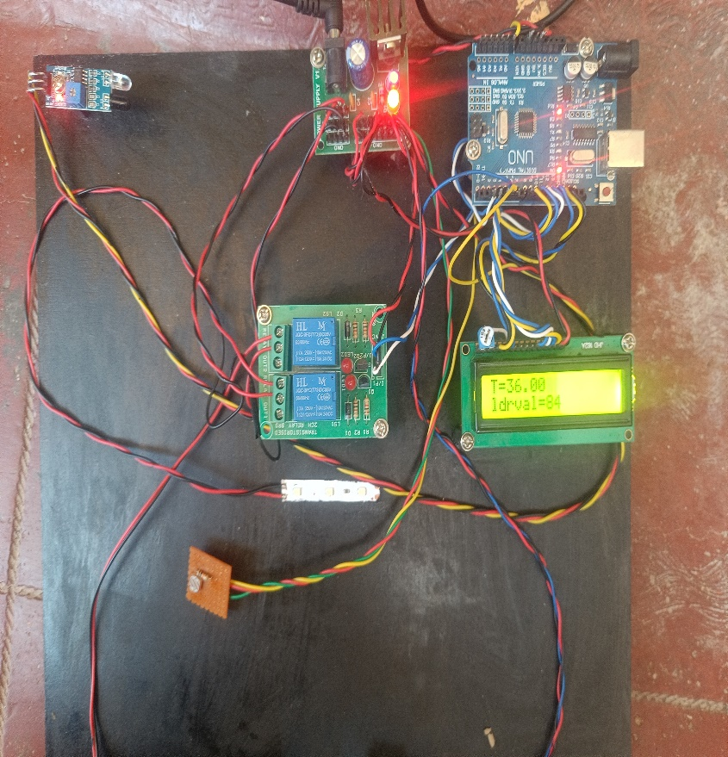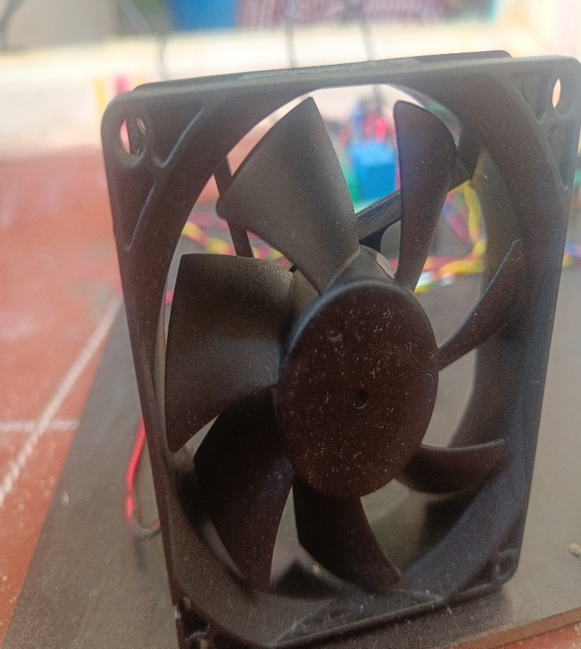

**Temperature sensor results when students detected (fan turns on) view:**

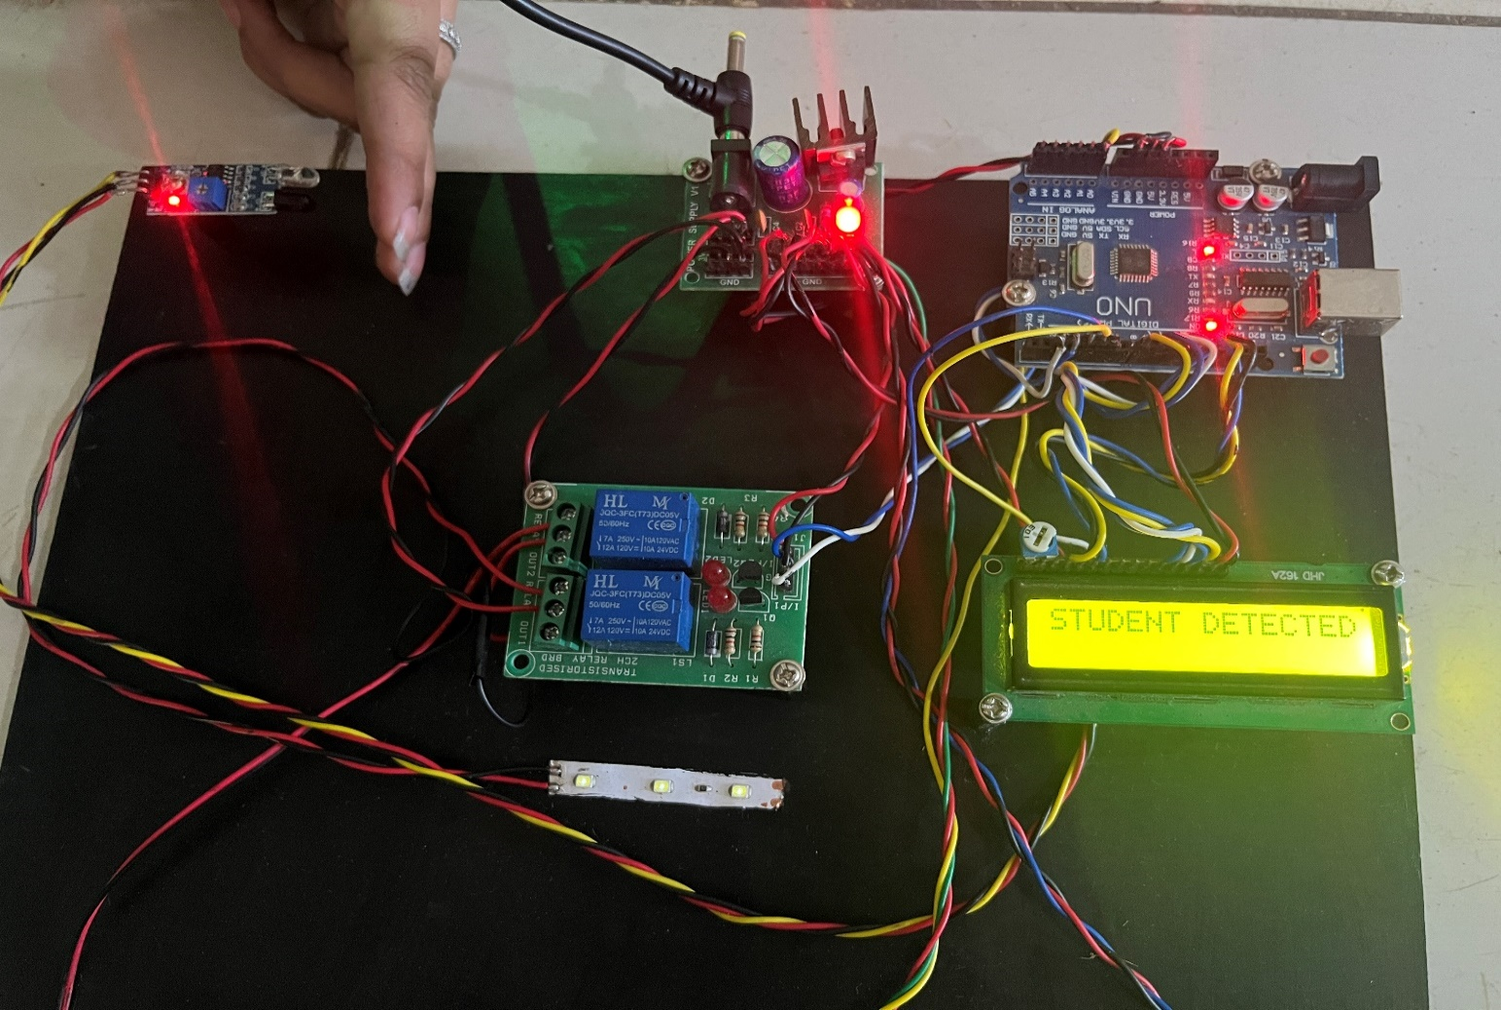

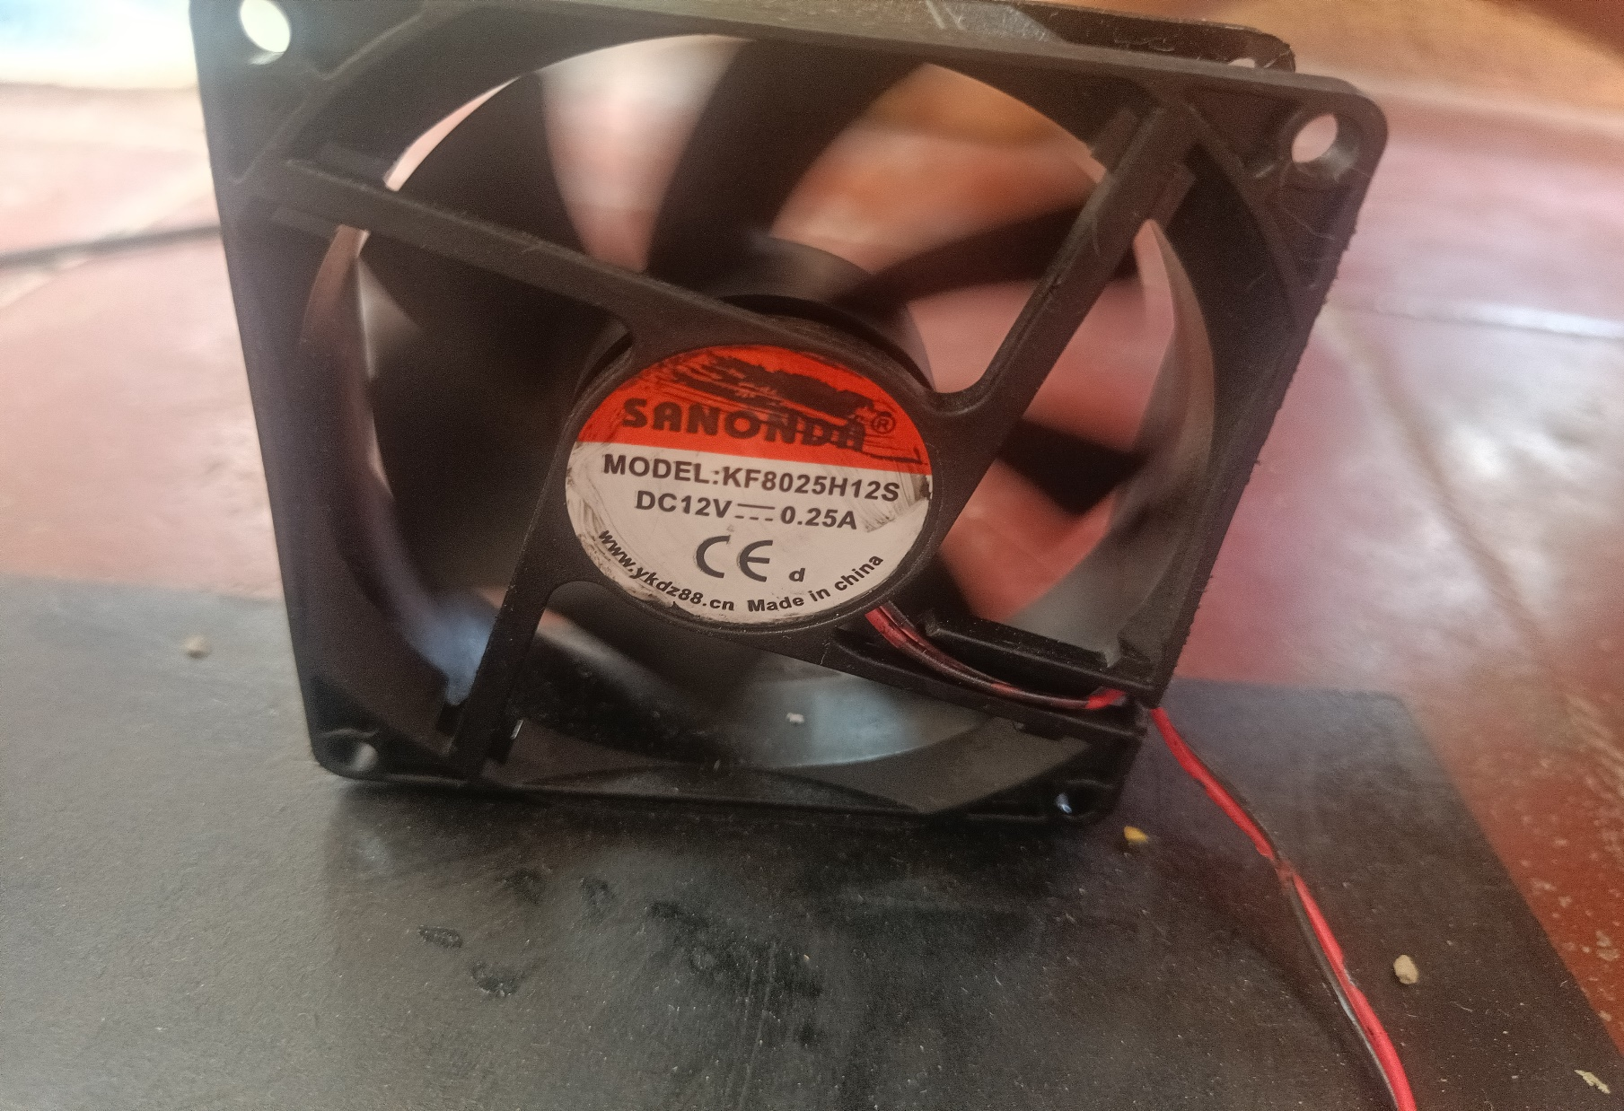

# REFERENCES

Implementation of IOT based Smart Security and Home Automation System by Md. Rakib Ahsan, Sheikh Zarif Ahmad, Mohammad Shamsul Arefin, Md.Aminul Bari in IJERT Volume 08, Issue 06 (June 2019) <https://www.ijert.org/implementation-of-iot-basedsmart-security-andhome-automation-system>

IoT based smart security and home automation system by Ravi Kishore Kodali; Vishal Jain; Suvadeep Bose; Lakshmi Boppana in 2016 International Conference on Computing, Communication and Automation (ICCCA) https://www.researchgate.net/publication/312559421_IoT_based_smart_security_and_home_ automation_system

Smart home — Automation and security system based on sensing mechanism by Mile Mrinal, L. Priyanka, Mashayak Saniya, Katkar Poonam, A.B. Gavali in Second International Conference on Electrical, Computer and Communication Technologies (ICECCT) 2017

An Approach Towards Building an IoT Based Smart Classroom by R. Ani; S. Krishna; H. Akhil; U Arun in 2018 International Conference on Advances in Computing, Communications and Informatics (ICACCI)

Karthik Krishnamurthi, S. Irudaya Mary, B. N. Sumalatha, Adler Pereira, “Fringer print based attendance system”, International Journal of Advanced Research in Computer and Communication Engineering, Vol. 4, Issue 3, March 2015

Vishvendra Pal Singh Nagar,” GSM led dot Matrix message display, International journal of advance research in science and engineering”, Vol. 04, issue 8 August 2015 International Journal of Trend in Scientific Research and Development (IJTSRD) ISSN: 2456-6470 @ IJTSRD | Available Online @ www.ijtsrd.com | Volume – 2 | Issue – 2 | Jan-Feb 2018 Page: 313

Vinay sagar K N,Kusuma S M, “Home automation using internet of things, International Research Journal of Engineering and Technology”, in International Research Journal For Engineering and Technology Volume : 02 Issue: 03 | June-2015

Md. Nahal Islam, Farah Tabassum, Gourab Kumar Sarker, Dhrubashish Sen, “Intelligent Classroom Management System” in BRAC University, December 2013

Harsh Mehta, Kunal Jadhav, Avinash Mishra,” Anushree Deshmukh, IoT Based Home Automation System Using Arduino Board”, International Research Journal of Engineering and Technology Volume: 04 Issue: 01 | Jan -2017